GED Math Practice Test

Q1. Danny worked 40 hours and earned $6.30 per hour. His friend Erica earned $8.40 per hour at her job. How many hours would Erica have to work in order to equal Danny’s earnings for 40 hours?
- A). 20
- B). 50
- C). 30
- D). 258
- E). Not enough information is given.
Answer : ___
Q2. ΔABC is a right triangle and \overline{\rm CD} ⊥ \overline{\rm AB}CD⊥AB . If the measure of ∠CAD = 40°, what is the measure of ∠DCB?
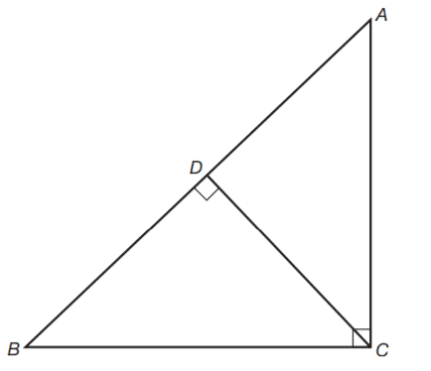
- A). 10°
- B). 20°
- C). 40°
- D). 60°
- E). 90°
Answer : ___

Q3. The number of students in a class is x. One day, 5 students were absent. What fractional part of the class was present?
- A). x/5
- B). 5/x
- C). 5 / x – 5
- D). x + 5 / 5
- E). x – 5 / 5
Answer : ___
Q4. The gauge on a water tank shows that the tank is 1/3 full of water. In order to fill the tank, 16 gallons of water are added. How many gallons of water does the tank hold when full?
- A). 20
- B). 24
- C). 28
- D). 32
- E). 42
Answer : ___
Q5. What is the length in feet of the ramp?
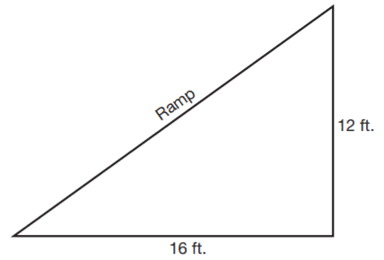
- A). 11
- B). 17
- C). 20
- D). 22
- E). 31
Answer : ___

Q6. At a luncheon, 48 half-pints of fruit juice are served. What is the cost, at $3.50 per gallon, of these servings of fruit juice?
- A). $6.00
- B). $7.00
- C). $10.50
- D). $15.50
- E). $17.50
Answer : ___
Q7. Given the equation x² + x − 6 = 0, which of the following give(s) a complete solution of the equation?
- A). 2
- B). 2 and −3
- C). −2 and 3
- D). 2 and 3
- E). 3 and −3
Answer : ___
Q8. What is the perimeter of the figure?
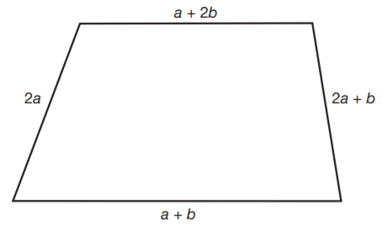
- A). 6a + b
- B). 5a + 5b
- C). 6a + 4b
- D). 3a + 5b
- E). 3a + 5b
Answer : ___
Q9. A rectangular dining room has a floor area of 322 square feet. If the length of the room is 23 feet, what is the perimeter?
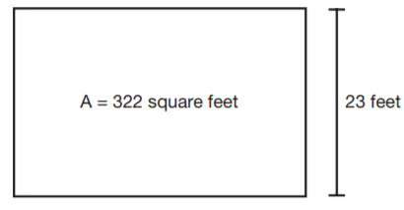
- A). 28 feet
- B). 38 feet
- C). 48 feet
- D). 58 feet
- E). 74 feet
Answer : ___
Q10. What is the perimeter of the figure?
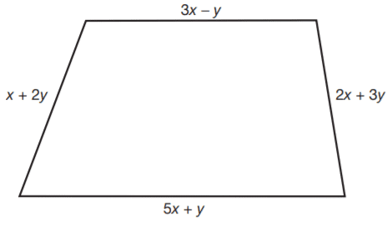
- A). 11x + 5y
- B). 10x + 5y
- C). 11x + 4y
- D). 9x − y
- E). 8x + 3y
Answer : ___
Q11. Henry has $5 more than Oliver, and the same amount of money as Murray. Together, they have $85. How much money does Oliver have?
- A). $10
- B). $20
- C). $25
- D). $45
- E). $55
Answer : ___

Q12. Question 12 is based on the following table.
This table gives the instructions that accompany an income tax form.
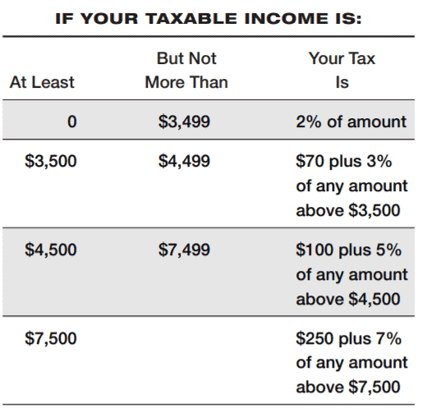
How much tax is due on a taxable income of $5,800?
- A). $120
- B). $130
- C). $165
- D). $175
- E). $220
Answer : ___
Q13. A bed and breakfast charges $48.00 per day for a double room. In addition, there is 5% tax. How much does a couple pay for several days’ stay?
- A). $144.20
- B). $151.20
- C). $156.20
- D). $158.40
- E). Not enough information is given.
Answer : ___

Q14. If \overline{\rm AC}AC is perpendicular to \overline{\rm CB}CB and m∠CBD = 125°, then m∠A equals
- A). 15°
- B). 25°
- C). 35°
- D). 45°
- E). Not enough information is given.
Answer : ___

Q15. If the square of a number is added to the number increased by 4, the result is 60. If n represents the number, which equation can be used to find n?
- A). n² + 4 = 60
- B). n² + 4n = 60
- C). n² + n + 4 = 60
- D). n² + 60 = 4n + 4
- E). n² + n = 64
Answer : ___
Q16. By how many dollars do the sales in the meat department exceed the sales in the dairy department?
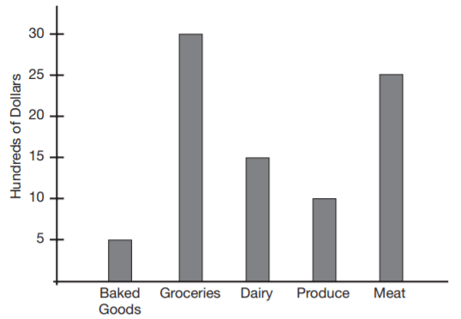
- A). $100
- B). $1,000
- C). $1,500
- D). $1,800
- E). $10,000
Answer : ___

Q17. A box of cereal is priced at x cents per box. A customer has a coupon for 15 cents off. If the store reduces prices by doubling the value of each coupon, how much, in cents, does the customer pay for the box of cereal?
- A). x − 15
- B). x − 30
- C). x + 15
- D). x + 30
- E). Not enough information is given.
Answer : ___
Q18. The measures of the angles of a triangle are in the ratio 3:2:1. What is the measure of the largest angle of the triangle?
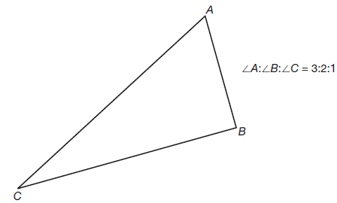
- A). 65°
- B). 70°
- C). 72°
- D). 80°
- E). 90°
Answer : ___

Q19. If m∠1 = 36° and m∠2 = 2(m∠3), then m∠3 equals
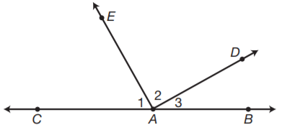
- A). 36°
- B). 48°
- C). 55°
- D). 58°
- E). 68°
Answer : ___

Q20. Ms. Klein bought 4 pounds of beef and 3(1/2) pounds of chicken for $13.98. If the beef cost $2.76 per pound, what was the cost of the chicken per pound?
- A). $0.72
- B). $0.80
- C). $0.84
- D). $0.87
- E). $0.92
Answer : ___
Q21. How many dollars were spent for labor?
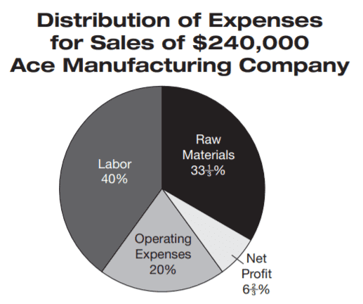
- A). $4,800
- B). $9,600
- C). $48,000
- D). $96,000
- E). $960,000
Answer : ___
Q22. The distance between two heavenly bodies is 63,150,000,000 miles. What is the number expressed in scientific notation?
- A). 631.5 ×10⁸
- B). 63.15 × 10⁹
- C). 6315 × 10⁷
- D). 6.315 × 10¹⁰
- E). 6.315 × 10⁻¹⁰
Answer : ___
Q23. What is the slope of the line passing through points A (5,4) and B (0,3)?
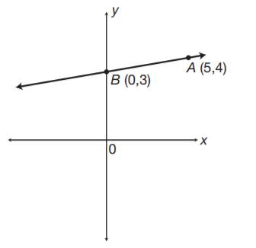
- A). 1/10
- B). 1/5
- C). 3/5
- D). 4/5
- E). 5
Answer : ___
Q24. 1 kilometer =
- A). 10 meters
- B). 100 meters
- C). 1,000 centimeters
- D). 10,000 centimeters
- E). 1,000,000 millimeters
Answer : ___
Q25. To measure the distance (DC) across a pond, a surveyor takes points A and B so that \overline{\rm AB}AB is parallel to \overline{\rm DC}DC. If \overline{\rm AB}AB = 60 feet, \overline{\rm EB}EB= 48 feet, and \overline{\rm ED}ED= 80 feet, find \overline{\rm DC}DC.
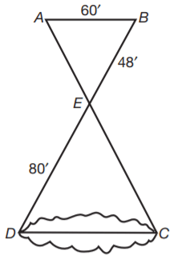
- A). 72 ft.
- B). 84 ft.
- C). 96 ft
- D). 100 ft.
- E). 200 ft.
Answer : ___
Q26. The graph shows what happens to each $100 taken in by a small business. How many dollars out of each $100 taken in represent profit?
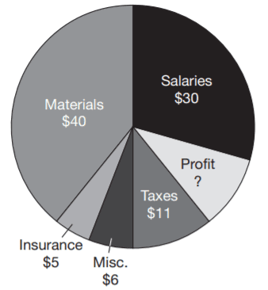
- A). $8
- B). $9.5
- C). $10
- D). $15
- E). $51
Answer : ___
Q27. Nick scored 7 more points than Josh in a basketball game. Paul scored 2 points less than Josh in the same game. If the three boys scored a total of 38 points, how many points did Josh score?
- A). 5
- B). 11
- C). 17
- D). 21
- E). 27
Answer : ___

Q28. A box in the form of a rectangle solid has a square base 5 feet in length and a height of h feet. If the volume of the rectangular solid is 200 cubic feet, which of the following equations may be used to find h?
- A). 5h = 200
- B). 15h = 200
- C). 25h = 200
- D). h = 200 ÷ 5
- E). h = 5(200)
Answer : ___

Q29. Which point on the number line represents the closest approximation to the square root of 12?
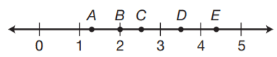
- A). A
- B). B
- C). C
- D). D
- E). E
Answer : ___
Q30. The diagram represents a large living room. What is the area, in square yards, of the room?
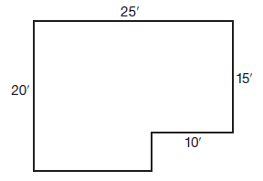
- A). 16.6
- B). 33.3
- C). 40
- D). 50
- E). 210
Answer : ___

Download Answers Keys and Solution
Link: https://gotestprep.com/ged-math-practice-test/

