Angles Practice Test Question Answers

Elementary Geometry: SET 1
1. In the following a pair of corresponding angles is

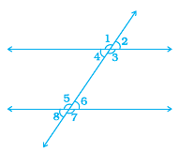
🔘 A. ∠1, ∠2 | 🔘 B. ∠2, ∠2
🔘 C. ∠3, ∠6 | 🔘 D. ∠4, ∠5
🔘 E. ∠3, ∠7
Answers
2. In the following figure AB||EF, ED||CB and ∠APE is 39°. Find ∠CQF.
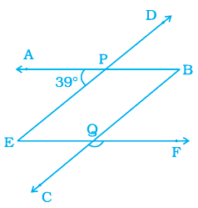
🔘 A. ∠CQF= 28⁰ | 🔘 B. ∠CQF= 39⁰
🔘 C. ∠CQF= 93⁰ | 🔘 D. ∠CQF= 139⁰
🔘 E. ∠CQF= 141⁰
Answers

3. Out of a pair of complementary angles, one is two-third of the other. Find the angles.
🔘 A. 18° | 🔘 B. 36°
🔘 C. 54° | 🔘 D. 90°
🔘 E. 180°
Answers

4. In the following figure CD intersects the line AB at F, ∠ CFB = 50° and ∠ EFA = ∠ AFD. Find the measure of ∠ EFC.
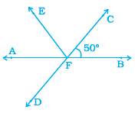
🔘 A. 50° | 🔘 B. 80°
🔘 C. 90° | 🔘 D. 120°
🔘 E. 180°
Answers
5. If the complement of an angle is 79°, then the angle will be of
🔘 A. 1° | 🔘 B. 10°
🔘 C. 11° | 🔘 D. 111°
🔘 E. 110°
Answers
6. In the following figure find the value of x is
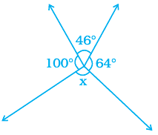
🔘 A. 46° | 🔘 B. 90°
🔘 C. 100° | 🔘 D. 110°
🔘 E. 150°
Answers
7. In the following figure if AB || CD, ∠ APQ = 50° and ∠PRD = 130°, then ∠ QPR is
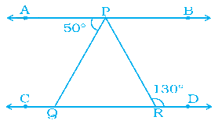
🔘 A. 20° | 🔘 B. 50°
🔘 C. 80° | 🔘 D. 90°
🔘 E. 130°
Answers
8. If angle A and angle B are supplementary and the measure of angle A is 60°, then the measure of angle B is
🔘 A. 30° | 🔘 B. 60°
🔘 C. 80° | 🔘 D. 90°
🔘 E. 120°
Answers
9. The measure of an angle which is four times its supplement is
🔘 A. 36° | 🔘 B. 90°
🔘 C. 110° | 🔘 D. 120°
🔘 E. 144°
Answers
10. In the following figure find the value of y
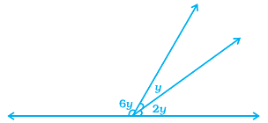
🔘 A. 10° | 🔘 B. 20°
🔘 C. 33° | 🔘 D. 45°
🔘 E. 60°
Answers

