Fractions and Decimals Practice Test 2: Question Answers

Fractions and Decimals Practice Test Question Answers

Test- 2
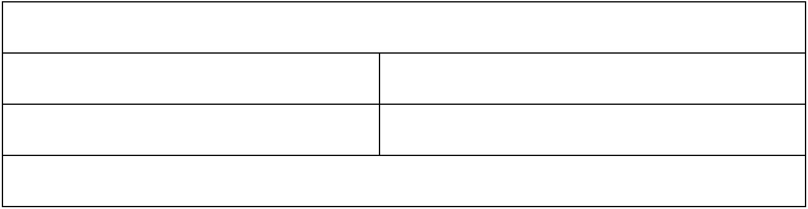

- How many ²₃ kg pieces can be cut from a cake of weight 4 kg?

A.2 B.6

C.8 D.10

e. 12

Show Answers

  - Lisa had a piece of rope length of 9.5 m. She needed some small pieces of rope of length 1.9 m each. How many pieces of the required length will she get out of this rope?
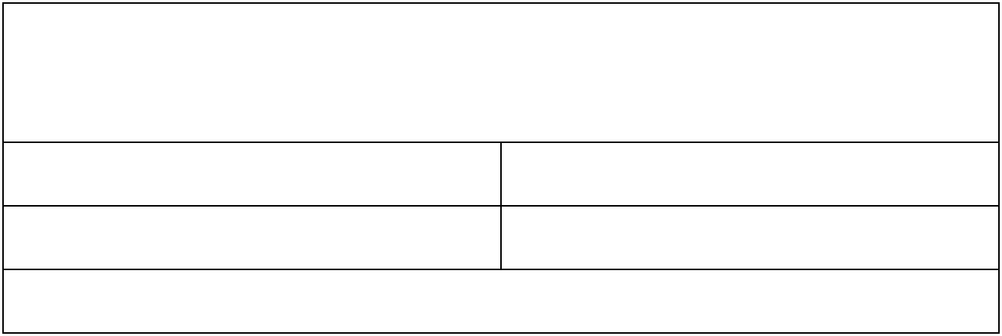

A. 3 pieces B. 5 pieces

C. 7 pieces D. 9 pieces

E. 13 pieces

Show Answer

3. Olivia uses | 3 | m of cloth to stitch a shirt. How many shirts can she make with | 2 | 1
3. Olivia uses | 4 |  | 2 | 4
m cloth? | 4 |  |  | 4
A. 1 |  | B. 2
C. 3 |  | D. 4
E. 5
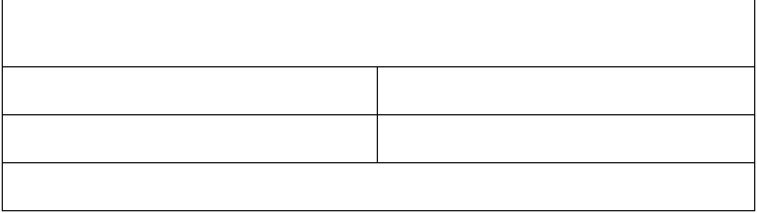

Show Answers

  - If the fraction of the frequencies of two notes has a common factor between the numerator and denominator, the two notes are harmonious. Use the graphic below to find the fraction of the frequency of notes D and B.
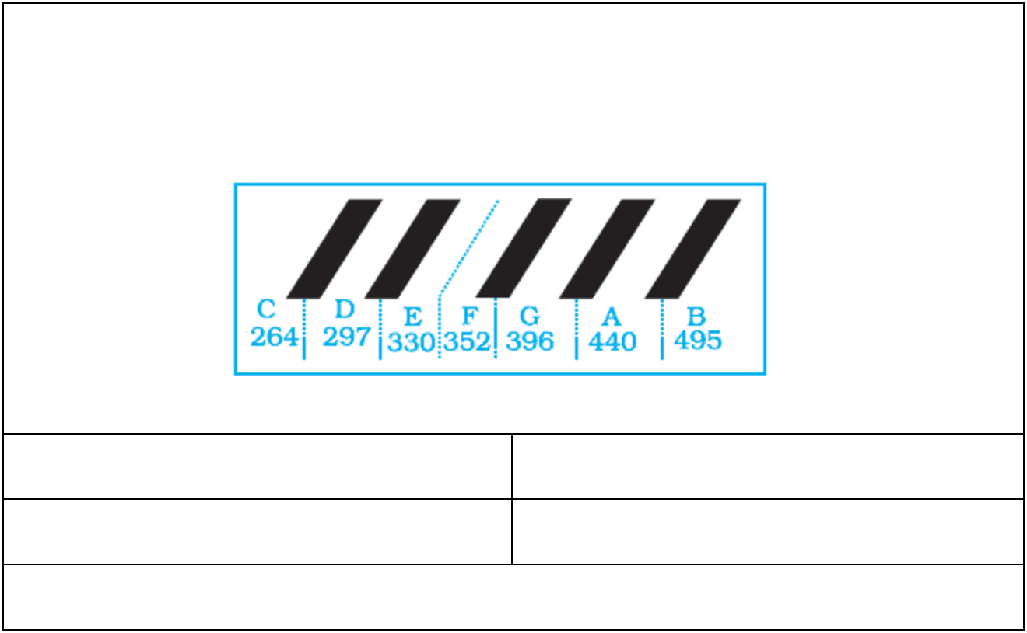

A. | 3 |  |  |  | B. | 5
A. | 5 |  |  |  | B. | 3
C. |  | 1 |  | D. |  |  | 3
C. | 5 |  |  |  |  | 1
E. | 1
E. | 3

Show Answers

  - Abigail said that we have gone about 120km or ²₃ of the way to the camp site. So, how much farther do we have to go?
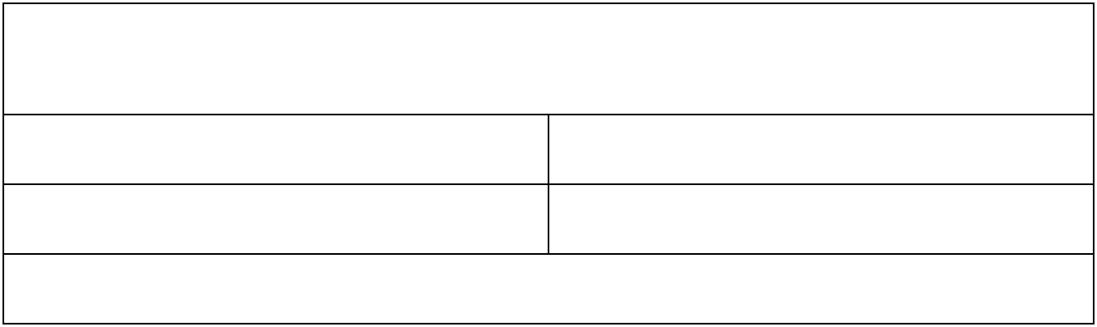

A. 20 km B. 40 km

C. 60 km D. 80 km

E. 100 km

Show Answers

https://gotestprep.com/fractions-and-decimals-test-2/ 2/4

6. | One KG Ice cream packet requires 2 | 1 | milks of flour and 1 | 2 | cups of sugar.
6. | One KG Ice cream packet requires 2 | 2 | milks of flour and 1 | 3 | cups of sugar.
Estimated total quantity of both ingredients used in 10 such packets of Ice cream will
be
A. between 10 cups and 20 cups |  |  | B. between 20 cups and 30 cups
C. between 30 cups and 40 cups |  |  | D. between 40 cups and 50 cups
E.above 50 cups
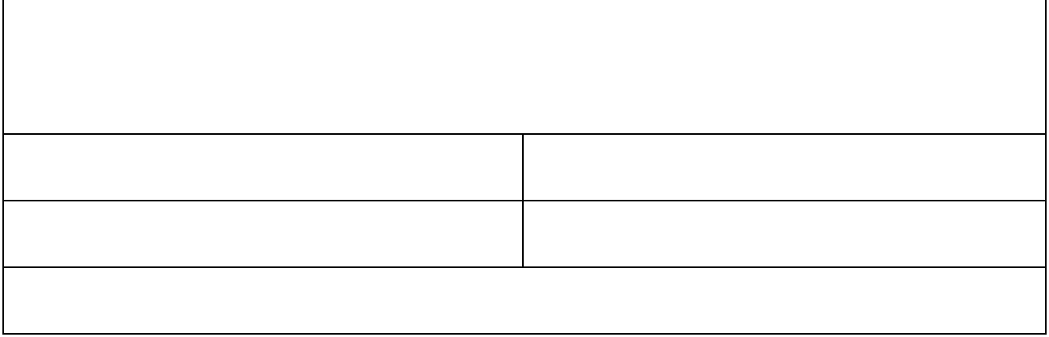

Show Answers

  - The following diagram interprets
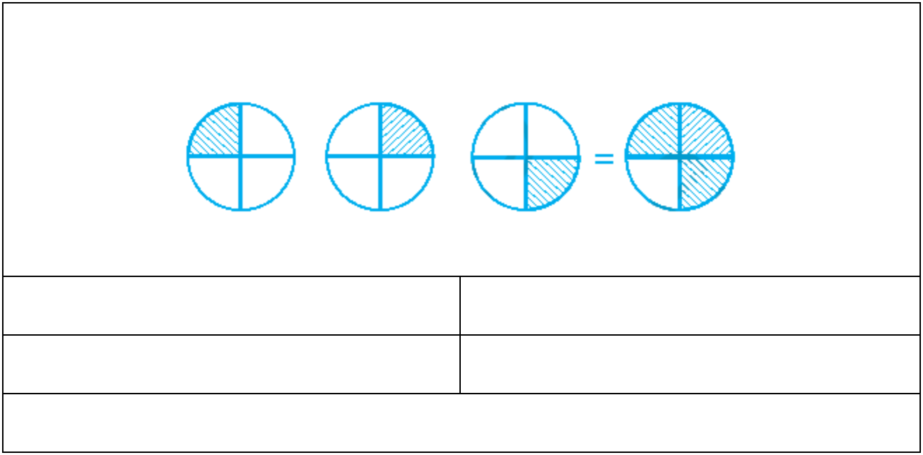

A. | 3 ÷ |  |  | 1 |  | B. | 3 |  | ÷ 3
A. |  |  |  |  |  | B. | 5
 |  |  | 3
C. |  | 1 | × 4 |  |  | D. 5÷ |  |  |  | 3
C. | 3
 |  |  |  |  |  |  |  |  | 5
E. | 3 × |  |  | 1
 |  |  | 4

Show Answers

  - Ava ate ²₇ part of a cake while her friend Emma ate ⁴₅ of the remaining. Find out the part of the cake is left.

A. | 1 |  |  |  | B. | 2
A. | 2 |  |  |  | B. | 3
C. |  | 1 |  | D. |  |  | 2
C. | 5 |  |  |  |  | 7
E. | 1
E. | 7

Show Answers

  - 2.001 ÷ 0.003

5/22/2020 | Fractions and Decimals Practice Test 2: Question Answers
A. 0.667 | B. 6.67
C. 06.67 | D. 667
E. 6677
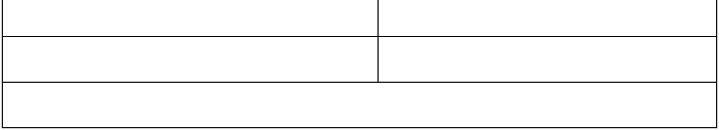

Show Answers

  - In a boy’s hostel (40 student), ¹₅ of students like to eat veg only, ²₅ of the total number of students like to eat non-veg only and the remaining students like to eat both. What fraction of the total number of students like to eat both?
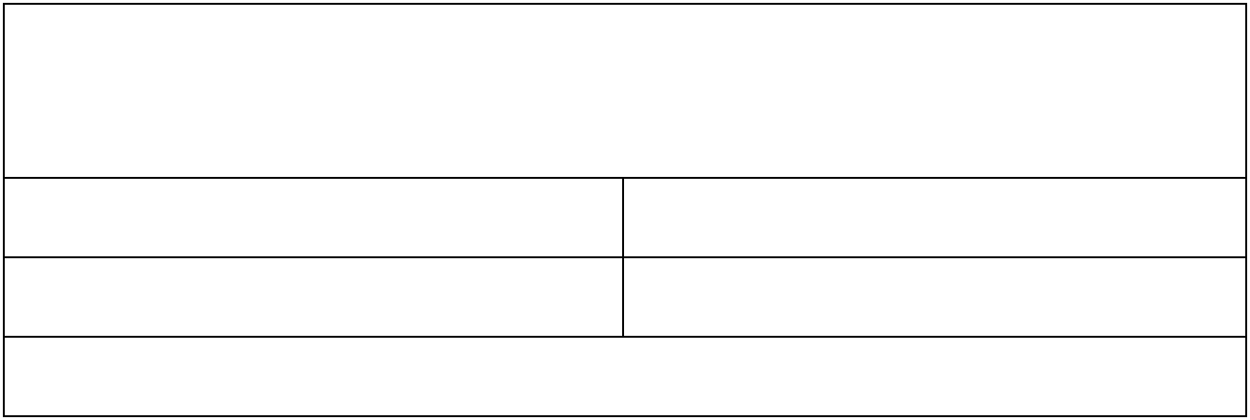

A. | 1 |  |  |  | B. | 2
A. | 5 |  |  |  | B. | 3
C. |  | 1 |  | D. |  |  | 1
C. | 3 |  |  |  |  | 2
E. | 2
E. | 5

Show Answers

Answer Keys: https://gotestprep.com/fractions-and-decimals-test-2/

