ACLS ECG Rhythm Strips Practice Test (Quiz)
Rhythm identification and Cardiac rhythm interpretation
Name the following rhythms from the questions below:
- Normal Sinus Rhythm NSR  - Sinus Tachycardia  - Supraventricular Tachycardia SVT  - Fine Ventricular Fibrillation  - Monomorphic VTach  - 2nd degree I Block  - 3rd degree block | - Sinus Bradycardia  - Atrial Flutter  - Atrial Fibrillation  - Coarse Ventricular Fibrillation  - Polymorphic VTach (Torsades)  - 2nd degree II Block  - Asystole

Q1.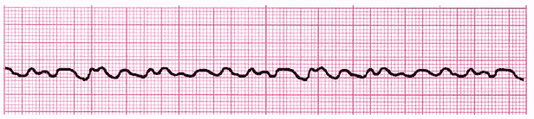
🔘 A. Supraventricular Tachycardia SVT | 🔘 D. Fine Ventricular Fibrillation
🔘 B. Sinus Tachycardia | 🔘 E. Sinus Brady
🔘 C. Coarse VFib | 🔘 F. Atrial Fibrillation
Your Answers

Q2.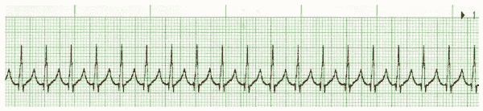
🔘 A. Supraventricular Tachycardia SVT | 🔘 D. NSR
🔘 B. Fine Ventricular Fibrillation | 🔘 E. SVT
🔘 C. 2nd degree Type II Block | 🔘 F. Asystole
Your Answers

Q3.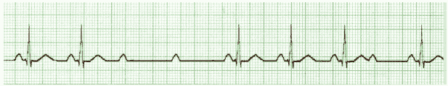
🔘 A. Polymorphic VTach | 🔘 D. Atrial Flutter
🔘 B. 3rd degree block | 🔘 E. Coarse Ventricular Fibrillation
🔘 C. 2nd degree Type II Block | 🔘 F. 2nd degree I Block
Your Answers

Q4.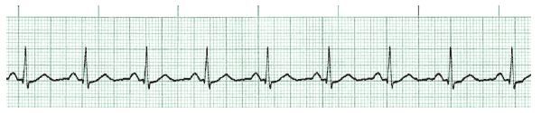
🔘 A. Normal Sinus Rhythm NSR | 🔘 D. Polymorphic VTach (Torsades)
🔘 B. Monomorphic VTach | 🔘 E. Atrial Flutter
🔘 C. 3rd degree Type II Block | 🔘 F. Asystole
Your Answers

Q5.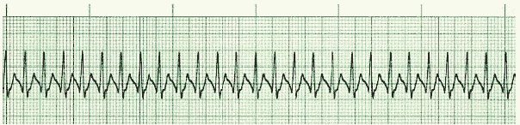
🔘 A. Fine VFib | 🔘 D. Fine Ventricular Fibrillation
🔘 B. Atrial Fibrillation | 🔘 E. Polymorphic VTach
🔘 C. Sinus Tachycardia | 🔘 F. SVT
Your Answers

Q6.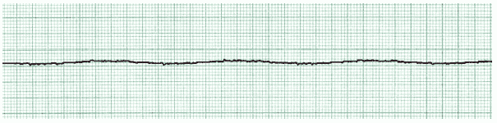
🔘 A. NSR | 🔘 D. Asystole
🔘 B. Monomorphic VTach | 🔘 E. Polymorphic VTach
🔘 C. Sinus Tachycardia | 🔘 F. Atrial Flutter
Your Answers

Q7.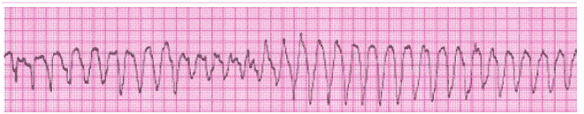
🔘 A. Sinus Brady | 🔘 D. Monomorphic VTach
🔘 B. Polymorphic VTach | 🔘 E. Atrial Fibrillation
🔘 C. Sinus Tachycardia | 🔘 F. Atrial Flutter
Your Answers

Q8.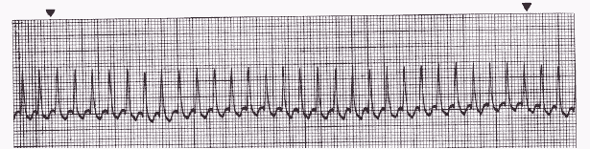
🔘 A. NSR | 🔘 D. SVT
🔘 B. 3rd degree Block | 🔘 E. Sinus Brady
🔘 C. Fine VFib | 🔘 F. Coarse VFib
Your Answers

Q9.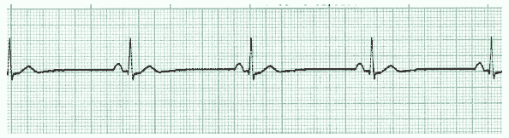
🔘 A. Sinus Brady | 🔘 D. Polymorphic VTach
🔘 B. Asystole | 🔘 E. NSR
🔘 C. SVT | 🔘 F. Fine VFib
Your Answers

Q10.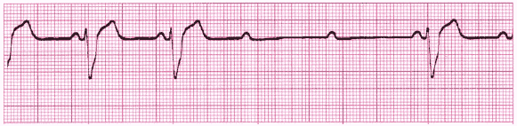
🔘 A. 3rd degree block | 🔘 D. 2nd degree I Block
🔘 B. 2nd degree II Block | 🔘 E. Monomorphic VTach
🔘 C. Sinus Tachycardia | 🔘 F. Asystole
Your Answers

