GED Math Practice Test 3

Q1. The dimensions of Box B, shown below, are twice the length of the corresponding dimensions on Box A (not shown).
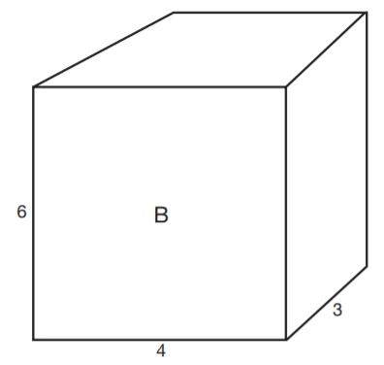
- A). The volume of Box A is greater than the volume of Box B.
- B). The volume of Box B is twice the volume of Box A.
- C). The volume of Box B is three times the volume of Box A.
- D). The volume of Box B is four times the volume of Box A.
- E). The volume of Box B is eight times the volume of Box A.
Answer : ___

Q2. At the end of baseball season, 5% of the children enrolled in a local youth baseball program will be chosen to play in the state tournament. If 12 children will be chosen to play in the tournament, how many children are enrolled in the
program?
- A). 24
- B). 60
- C). 120
- D). 240
- E). 600
Answer : ___
Q3. A bag contains 12 red, 3 blue, 6 green, and 4 yellow marbles. If a marble is drawn from the bag at random, what is the probability that the marble will be either blue or yellow?
- A). 7%
- B). 12%
- C). 16%
- D). 25%
- E). 28%
Answer : ___

Q4. Patricia wants to order business cards. A printing company determines the cost (C) to the customer using the following function, where b = the number of boxes of cards and n = number of ink colors.
C = $25.60b + $14.00b(n − 1) If Patricia orders 4 boxes of cards printed in 3 colors, how much will the cards cost?
- A). $214.40
- B). $168.00
- C). $144.40
- D). $102.40
- E). $56.00
Answer : ___

Q5. Andrea bought a used mountain bike for $250. She gave the bike a new paint job; replaced the tires, chain, and gear assembly; and sold the bike for 150% of the price she paid. For what amount, in dollars, did she sell the bike?
- (You may have to enter the correct value)
Answer : ___
Q6. Ajani finds that the distance between two landmarks on a map is 6 (½) inches. If the map scale reads ¾ inch = 120 miles, what is the actual distance, in miles, between the two landmarks?
- (You may have to enter the correct value)
Answer : ___
Q7. Which of the following is a graph of the inequality −2 ≤ x < 4?
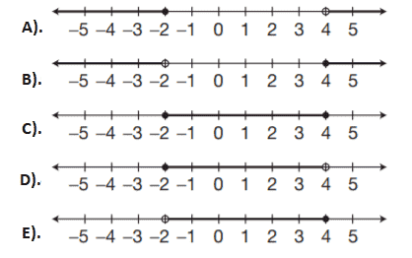
Answer : ___
Questions 8 and 9 are based on the following figure.
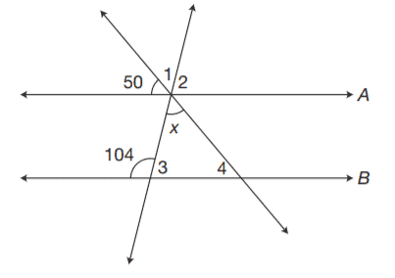
Lines A and B are parallel.
Q8. What is the measure of ∠4?
- A). 50°
- B). 76°
- C). 126°
- D). 130°
- E). 104°
Answer : ___
Q9. What is the value of x?
- A). 54°
- B). 76°
- C). 126°
- D). 130°
- E). Not enough information is given
Answer : ___

Q10. On a coordinate plane, a vertical line is drawn through the point (−3,4). On the same plane, a horizontal line is drawn through the point (2,−1). At what point on the plane will the two lines intersect?
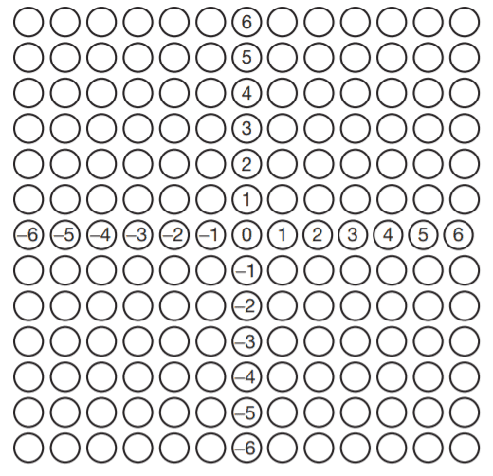
- You may have to answer on the coordinate grid (screen)
Answer : ___
Q11. What was Edmundo’s mean score for a round of golf in August if his scores for each round were 78, 86, 82, 81, 82, and 77?
- A). 77
- B). 78
- C). 81
- D). 81
- E). 84
Answer : ___
Q12. In quadrilateral ABCD, side AB is parallel to side CD. Sides AD and BC are not parallel. What is the area of the figure to the nearest square centimeter?
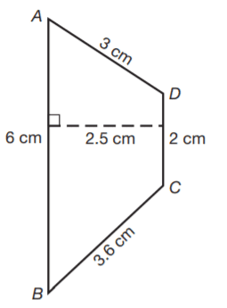
- A). 10 cm²
- B). 12 cm²
- C). 14 cm²
- D). 18 cm²
- E). 20 cm²
Answer : ___

Q13. A display of canned yams has a sign that reads “5 cans for $3.” At the same rate, how much would the store charge, to the nearest whole cent, for 8 cans?
- A). 1.80
- B). 2.80
- C). 3.80
- D). 4.80
- E). 8.80
Answer : ___
Q14. A plastic pipe, 5 feet 9 inches long, is cut into three equal pieces. Assuming no waste when the cuts are made, what is the length of each piece?
- A). 1 ft. 6 in.
- B). 1 ft. 8 in.
- C). 1 ft. 9 in.
- D). 1 ft. 11 in.
- E). 2 ft.
Answer : ___
Q15. The Wrights plan to carpet their bedroom and the adjoining hallway as shown in the diagram. What is the area of the bedroom and hallway in square feet?
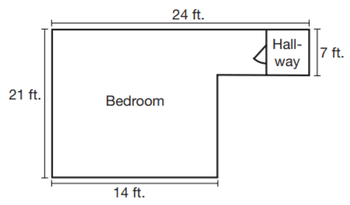
- A). 147
- B). 336
- C). 294
- D). 364
- E). 504
Answer : ___
Q16. One number is 12 more than 3 times another number. The sum of the 2 numbers is −20. What are the numbers?
- A). −2 and −18
- B). −4 and −16
- C). −5 and −15
- D). −6 and −14
- E). −8 and −12
Answer : ___

Questions 17 and 18 refer to the following graph.
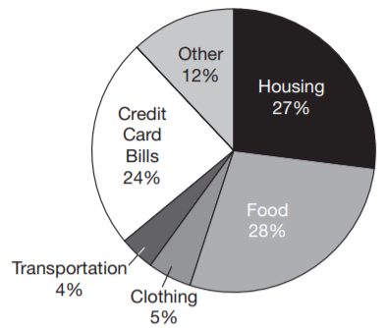
The Kleins are trying to pay off their credit card debt, so they developed the following budget based on their monthly take-home pay.
Q17. If the Kleins’ monthly take-home pay is $2,500, about how much do they plan to pay each month on their credit card debt?
- A). $600
- B). $450
- C). $300
- D). $240
- E). Not enough information is given.
Answer : ___
Q18. What fraction of the Kleins’ monthly take-home pay goes toward clothing?
- A). 1/20
- B). 3/20
- C). 1/40
- D). 2/40
- E). 3/50
Answer : ___
Q19. The graph of the equation y = − (3/4) x + 1 is a line that passes through points C and D on the coordinate plane. Which of the following points also lies on the graph of the equation?
- A). (2,0)
- B). (3,−1)
- C). (5,−3)
- D). (8,−5)
- E). . (10,−6)
Answer : ___

Q20. The sum of three consecutive even integers is 90. What is the greatest number in the series?
- A). 26
- B). 28
- C). 30
- D). 32
- E). 34
Answer : ___

Q21. The three interior angles of ΔJKL measure 45°, 45°, and 90°. The three interior angles of ΔPQR measure 45°, 45°, and 90°. The side JK of JKL measures 4 cm. Based on the given information, which of the following must be a true statement?
- A). Δ JKL and ΔPQR are acute triangles.
- B). One side of ΔPQR measures 4 cm
- C). The perimeter of ΔJKL is 12 cm.
- D). ΔJKL and ΔPQR are congruent triangles.
- E). ΔJKL and ΔPQR are similar triangles.
Answer : ___
Q22. A parallelogram is drawn on a coordinate grid so that three vertices are located at (3,4), (−2,4), and (−4,1). At what coordinates should the fourth vertex be located?
Answer : ___

Q23. Eight athletes ran a 1 mile race. The winner’s time was 4 minutes 8 seconds. If the median time was 4 minutes 48 seconds, what was the time of the athlete who finished last?
- A). 5 min. 28 sec.
- B). 5 min. 4 sec.
- C). 4 min. 46 sec.
- D). 4 min. 28 sec.
- E). Not enough information is given.
Answer : ___
Questions 24 and 25 refer to the following information.
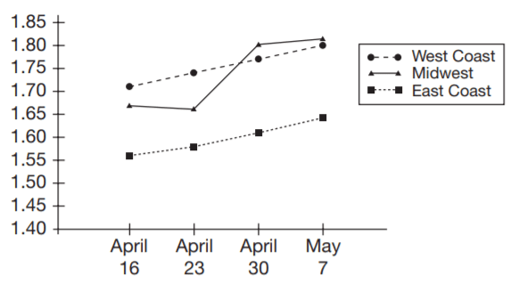
Q24. On what date and in what location was there the greatest jump in the price of gasoline from one week to the next?
- A). April 23 on the West Coast
- B). April 30 in the Midwest
- C). April 30 on the West Coast
- D). May 7 on the East Coast
- E). May 7 in the Midwest
Answer : ___
Q25. Based on the information in the graph, which of the following is the best prediction of the price per gallon of gasoline on the West Coast for the week following May 7?
- A). $1.64
- B). $1.71
- C). $1.76
- D). $1.82
- E). $1.86
Answer : ___
Q26. Chikita made three long-distance calls. According to her phone bill, the calls were 19 minutes, 24 minutes, and 8 minutes in length. If Chikita pays 9 cents per minute on all long-distance calls, how much was she billed for the three calls?
- A). $2.70
- B). $4.59
- C). $5.10
- D). $13.77
- E). $15.30
Answer : ___
Q27. Maggie and Christian decided to share the cost of buying their friends a wedding gift. Maggie put in $20 less than twice the amount that Christian contributed. Together, they spent $94. How many dollars did Maggie contribute toward the gift?
- A). $56
- B). $76
- C). $86
- D). $96
- E). $106
Answer : ___

Q28. The Northridge Quakers have won 20 games and lost 15. What is the ratio of games won to game played?
- A). 3:4
- B). 3:7
- C). 4:3
- D). 4:7
- E). 4:10
Answer : ___
Q29. To set up a tent, workers place a 25-foot pole in the center of a grassy area as shown in the diagram. A bracing wire is attached to the top of the pole and to a stake 9 feet from the base of the pole. Which of the following represents the
length of the bracing wire?
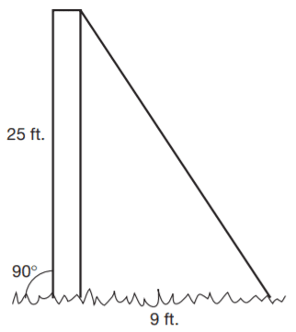
- A). √1156
- B). √706
- C). √625
- D). √256
- E). √34
Answer : ___

Q30. What is the value of the expression −3 × 5² + 2(4 − 18) + 3²?
- A). −130
- B). −76
- C). −20
- D). 74
- E). 130
Answer : ___

Q31. The lengths of the sides of ΔABC are 6 inches, 8 inches, and 10 inches. Which of the following conclusions must be true?
- A). ∠C is a right angle
- B). ΔABC is an acute triangle.
- C). ΔABC contains one obtuse angle.
- D). ∠A is an acute angle.
- E). m∠A + m∠B + m∠C = 180°
Answer : ___

Q32. Two sides of a triangle measure 6 and 10 inches. If the triangle is a right triangle, which of the following could be the measure, in inches, of the third side?
- A). 4
- B). 6
- C). 8
- D). 10
- E). 12
Answer : ___
Q33. Classify the figure containing interior angles 3, 6, 11, and 13.
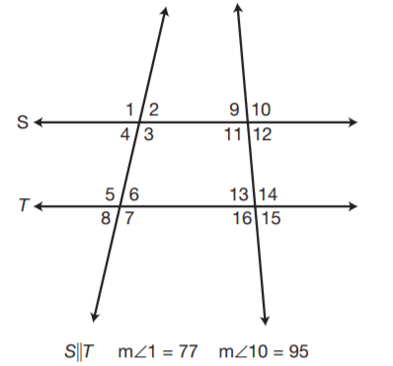
- A). scalene triangle
- B). trapezoid
- C). parallelogram
- D). rectangle
- E). square
Answer : ___
Q34. The floor of a walk-in closet measures 7 feet by 4 feet. If the ceiling height is 8 feet, what is the volume in cubic feet of the closet?
- A). 28
- B). 56
- C). 112
- D). 168
- E). 224
Answer : ___
Q35. In a right triangle, the hypotenuse measures 15 inches. If one leg of the triangle measures 6 inches, which of the following equations could be used to find the length of the other leg (x) in inches?
- A). x = 15 + 6
- B). x = 15 − 6
- C). x = 15 − 6
- D). x² = 15² + 6²
- E). x² = 15² − 6²
Answer : ___
Answer Keys and Explanation Link
https://gotestprep.com/ged-math-test-answers-printable-pdf/

