GED Math Practice Test 2

Q1. If 1 dollar is worth x French francs, what is the value, in dollars, of y French francs?
- A). xy
- B). x/y
- C). y/x
- D). 1/yx
- E). x+y
Answer : ___
Q2. Evaluate y ²4x − y) if y = −2 and x = 8.
- A). -18
- B). 8
- C). 86
- D). 96
- E). 136
Answer : ___
Q3. On a road map, 1/4 inch represents 8 miles of actual road distance. The towns of Alton and Waverly are represented by points 2 (1/8) inches apart on the map. What is the actual distance, in miles, between Alton and Waverly?
- A). 17
- B). 32
- C). 40
- D). 60
- E). 68
Answer : ___
Q4. What is the area, in square graph units, of the triangle?
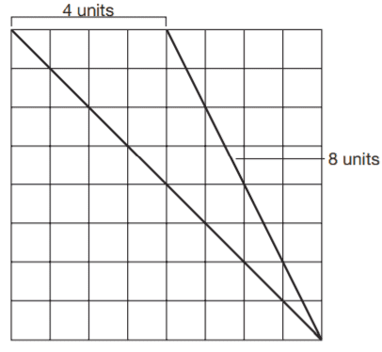
- A). 8
- B). 10
- C). 16
- D). 32
- E). 48
Answer : ___
Q5. At a certain time of day, a man 6 feet tall casts a shadow 4 feet in length. At the same time, a church steeple casts a shadow 28 feet in length. How high, in feet, is the church steeple?
- A). 30
- B). 32
- C). 42
- D). 48
- E). 56
Answer : ___

Questions 6 through 8 are based on the following information.
A 3-foot-wide walkway is built around a swimming pool that is 20 feet by 30 feet, as shown in the following figure.
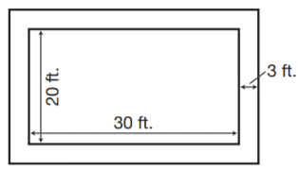
Q6. In order to determine how much flagstone to buy, the homeowner needs to know the total area, in square feet, of the walkway. Which of the following expressions represents this area?
- A). (23)(33)
- B). (26)(36)
- C). (23)(33) − (20)(30)
- D). (26)(36) − (20)(30)
- E). . (26)(36) − (23)(33)
Answer : ___

Q7. If the depth of the pool is 6 feet, what volume of water, in cubic feet, is needed to fill the pool?
- A). 56
- B). 300
- C). 600
- D). 300
- E). 3600
Answer : ___
Q8. What is the total area, in square feet, of the pool and the walkway?
- A). 50
- B). 62
- C). 759
- D). 936
- E). 1236
Answer : ___
Q9. Evaluate (6 × 10⁵) ÷ (4 × 10³).
- A). 20
- B). 100
- C). 150
- D). 1500
- E). 2000
Answer : ___

Q10. A house and a lot cost $120,000. If the house cost three times as much as the lot, how much did the house cost?
- A). $30,000
- B). $40,000
- C). $60,000
- D). $90,000
- E). $120,000
Answer : ___

Q11. Joan borrowed $1,300 to buy tools for her job as an auto mechanic. The loan is for one year and six months at 9% simple interest. Which of the following expressions could be used to find the amount she will pay back at the end of the loan period?
- A). $1,300 × 1.5 × 0.09
- B). $1,300 × 1.6 × 0.09
- C). $1,300 × 1.5 × 9
- D). $1,300 + ($1,300 × 9 × 1.5)
- E). $1,300 + ($1,300 × 0.09 × 1.5)
Answer : ___

Q12. Norm borrows $8,000 for five years to make improvements to his home office. If the simple interest rate is 13%, how much will he pay in interest?
- A). $5,200
- B). $4,000
- C). $1,040
- D). $420
- E). $400
Answer : ___
Q13. The solution x = −5 makes which of the following equations true?
- A). 14 − x = 9
- B). x + 3 = 8
- C). 12x = −60
- D). 2x = 20
- E). 2x + 12 = 9
Answer : ___

Q14. Marc had $572.18 in his checking account. After writing a check, he had $434.68. Which of the following equations could be used to find the amount of the check (c)?
- A). $572.18 + c = $434.68
- B). $572.18 − c = $434.68
- C). $572.18c = $434.68
- D). $572.18 − 2c = $434.68
- E). $434.68 + c = $572.18
Answer : ___
Q15. Ken earned x dollars at his part-time job on Friday. His wife earned $12 more than twice Ken’s pay (2x + 12). Together, they earned $174. How much did Ken earn on Friday?
- A). $54
- B). $87
- C). $108
- D). $120
- E). $162
Answer : ___

Q16. Two adults and four children pay $48 to get into the fair. A child’s ticket is $6 less than an adult’s ticket. What is the cost of an adult’s ticket?
- A). $18
- B). $15
- C). $12
- D). $9
- E). $6
Answer : ___

Q17. What is the median value of $268, $1,258, $654, $1,258, $900, $1,558, and $852?
- A). $1,258
- B). $960
- C). $900
- D). $913
- E). $852
Answer : ___
Q18. What is the mode of the following: 14, 17, 14, 12, 13, 15, 22, and 11?
- A). 13.5
- B). 14
- C). 14.75
- D). 16.5
- E). Not enough information is given.
Answer : ___
Q19. Charlie borrowed $1,500 from his aunt. He plans to pay his aunt back in nine months. If he pays 4% interest on the loan, what is the total amount he will pay back in nine months?
- A). $540
- B). $1,455
- C). $1,545
- D). $1,560
- E). $2,040
Answer : ___
Q20. Max needs to ship six identical packages, each weighing 3 lb. 12 oz. What is the total weight of the shipment?
- A). 19 lb. 2 oz.
- B). 22 lb. 5 oz.
- C). 22 lb. 8 oz.
- D). 24 lb. 12 oz.
- E). 25 lb. 2 oz.
Answer : ___

Q21. In a theater audience of 650 people, 80% were adults. How many children were in the audience?
- A). 130
- B). 150
- C). 450
- D). 500
- E). 520
Answer : ___
Q22. On a certain map, 1 inch represents 60 miles. If two towns are 255 miles apart, what is the distance, in inches, between the towns on the map?
- A). 4
- B). 4 (1/4)
- C). 4 (1/2)
- D). 4 (5/6)
- E). 4 (7/4)
Answer : ___
Q23. A carpenter has a board 4 feet 3 inches in length. He cuts off a piece 2 feet 8 inches in length. The length of the piece that is left is
- A). 1 ft. 5 in.
- B). 1 ft. 7 in.
- C). 2 ft. 7 in.
- D). 2 ft. 5 in.
- E). 2 ft. 3 in.
Answer : ___
Q24. A cardboard crate is 5 feet long, 3 feet wide, and 2 feet tall. What is its holding capacity?
- A). 45 ft.³
- B). 37 ft.³
- C). 9 ft.³
- D). 30 ft.³
- E). 10 ft.³
Answer : ___
Questions 25 through 27 are based on the following graph.
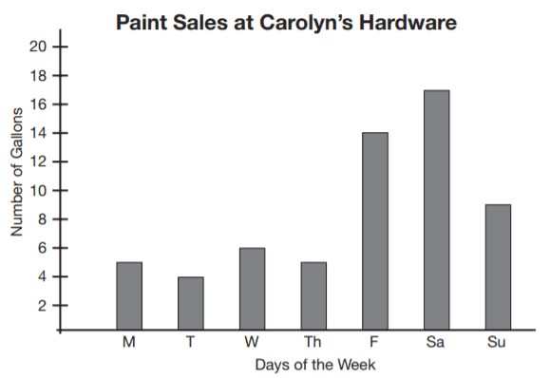
Q25. How many gallons of paint were sold on Wednesday?
- A). 3
- B). 4
- C). 5
- D). 6
- E). 9
Answer : ___
Q26. How much more paint was sold on Saturday than on Monday?
- A). 6 gallons
- B). 8 gallons
- C). 10 gallons
- D). 11 gallons
- E). 12 gallons
Answer : ___

Q27. What was the total amount, in gallons, of paint sold by the store that week?
- A). 20
- B). 25
- C). 30
- D). 60
- E). Not enough information is given.
Answer : ___
Q28. O is the center of the circle, and the measure of ∠O is 70°. What is the measure of ∠OAB?
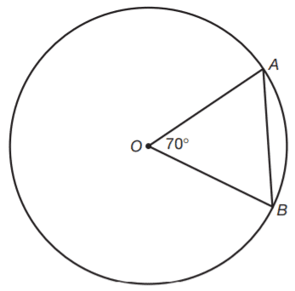
- A). 55°
- B). 60°
- C). 70°
- D). 75°
- E). 95°
Answer : ___

Q29. A bookcase has 3 large shelves and 4 small shelves. Each large shelf contains 8 more books than each small shelf. If the bookcase contains 297 books, how many books does each small shelf hold?
- A). 29
- B). 31
- C). 32
- D). 35
- E). 39
Answer : ___

Q30. Ms. Kraus buys 40 feet of wool to use for scarves. How many scarves of 3 feet 4 inches each in length can she cut from this material, assuming each scarf is as wide as the original piece of fabric?
- A). 12
- B). 15
- C). 16
- D). 18
- E). 120
Answer : ___
Questions 31 and 32 refer to the following graph.
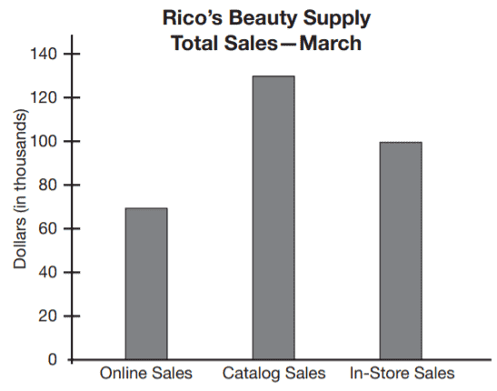
Q31. Customers of Rico’s Beauty Supply can make purchases online, from a catalog, or in the store. About how much more did the company make from catalog sales than from online sales in March?
- A). $35,000
- B). $65,000
- C). $130,000
- D). $195,000
- E). $650,000
Answer : ___
Q32. Approximately what fraction of the company’s total sales came from in-store sales?
- A). 2/3
- B). 1/3
- C). 1/2
- D). 1/4
- E). 1/6
Answer : ___
Q33. Josh needs to replace the boards on a 22-foot section of his fence. If the boards are 5 (1/2) inches wide, how many boards should he buy to cover the distance?
- A). 4
- B). 33
- C). 48
- D). 66
- E). 121
Answer : ___
Question 34 refers to the following graph.
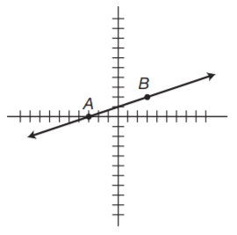
Q34. What is the slope of the line that passes through points A and B on the coordinate graph?
- [In the examination, you have to enter the correct value]
Answer : ___
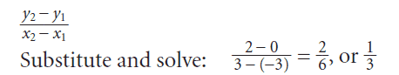
Q35. What is the value of the expression 3(2x − y) + (3 + x)2, when x = 4 and y = 5?
- [In the examination, you have to enter the correct value]
Answer : ___

Download Answers Keys and Solution
Link: https://gotestprep.com/ged-math-test-question-pdf/

