GED Science Practice Test 2
Q1. A solar eclipse occurs when the moon blocks our view of the sun. Select the diagram that best represents the position of the sun, the Earth, and the moon during a solar eclipse, as well as the correct orbits
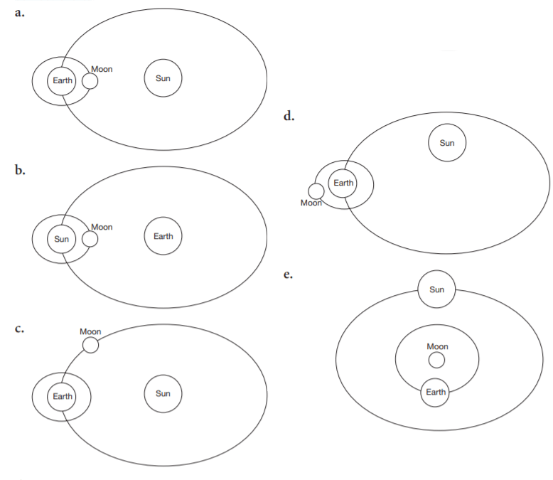
Answer: _____

Q2. Convection currents of molten rock within the Earth mantle cause all the following EXCEPT
- A). sunlight.
- B). movement of plates on Earth’s crust.
- C). volcanic eruptions.
- D). earthquakes.
- E). flow of molten rock from cracks along the bottom of the ocean.
Answer: _____

Q3. Which of the following does NOT cause changes in the Earth’s surface, such as the formation of mountains and valleys?
- A). collision of plates
- B). moving apart of plates
- C). volcanic eruptions
- D). erosion
- E). ozone
Answer: _____

Q4.The United States is in the Northern Hemisphere. Which statement(s) about the Southern Hemisphere is true?
I). It is always warm in the Southern Hemisphere.
II). When it’s summer in the Northern Hemisphere, it is winter in the Southern Hemisphere.
III). In the Southern Hemisphere, the sun sets in the east.
IV). When it’s winter in the Northern Hemisphere, it is summer in the SouthernHemisphere.
- A). statement I only
- B). statement II only
- C). statements II, III, and IV
- D). statements II and IV
- E). statements I, II, and IV
Answer: _____

Q5. Humidity is a measure of
- A). air temperature.
- B). the amount of water vapor in air.
- C). air pressure.
- D). cloudiness.
- E). air resistance.
Answer: _____

Q6. The Milky Way is estimated to be about 100,000 light-years across its larger diameter. A light-year is a measure of
- A). time since the Big Bang.
- B). distance.
- C). brightness.
- D). the number of stars in a galaxy.
- E). speed of light.
Answer: _____

Questions 7 and 8 are based on the following passage
According to scientists, the sun has existed for 4.6 billion years. The sun produces energy by a nuclear conversion of hydrogen into helium.
When hydrogen runs out, according to this theory, the sun will expand, engulfing Earth and other planets. Not to worry—the expansion will not affect us, since the sun has enough hydrogen for another 4.6 billion years. When it expands, the sun will become what is called a red giant star. In another 500 million years, the sun will shrink to the current size of the Earth and will be called a white dwarf, cooling down for several billion years.
Q7. According to the passage, the sun will eventually
- A). expand and then shrink.
- B). shrink and then expand
- C). shrink and then run out of helium.
- D). expand because it ran out of helium.
- E). shrink because it ran out of hydrogen.
Answer: _____

Q8. Based on this theory, the sun will, at some point, be a
- A). blue star.
- B). red dwarf star
- C). white dwarf star.
- D). asteroid.
- E). galaxy.
Answer: _____

Q9. Webbed feet enable ducks to swim better by
- A). making the ducks aerodynamic.
- B). increasing the surface area with which ducks propel water
- C). preventing particles from being stuck between the duck’s toes.
- D). making the duck less dense
- E). increasing the rate of heat loss, so that ducks can cool down faster.
Answer: _____

Q10. Determine how much water is in the graduated cylinder drawn below by reading the bottom of the meniscus (surface of water).
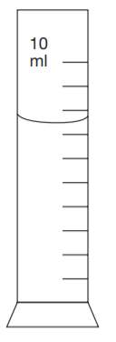
- A). 3.0 ml
- B). 5.5 ml
- C). 6.5 ml
- D). 7.5 ml
- E). 10.0 ml
Answer: _____

Q11. In addition to magnifying the image of an object, a microscope inverts the image left to right. The image of the object observed through the microscope is also upside down. Looking through the eyepiece, you would therefore see the upside-down mirror image of the object under the microscope lens. What would the object below look like if observed through the microscope?
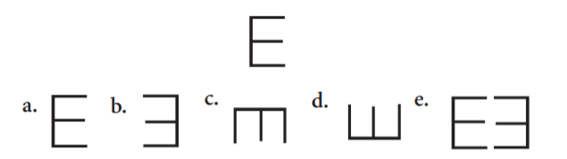
Answer: _____

Q12. Which one of the following statements is an opinion, rather than a fact?
- A). All organisms are made of one or more cells.
- B). It’s wrong to kill any organism.
- C). All organisms need energy
- D). Some organisms reproduce asexually.
- E). Some organisms can breathe underwater.
Answer: _____

Q13. Here are a few experimental observations and known facts:
I. A scummy substance often forms in solutions of an amino acid in water.
II. When the water is purified and exposed to UV radiation, the scummy substance does not form in the amino acid solution.
III. UV radiation kills bacteria.
What would be a valid hypothesis based on I, II and III?
- A). The scummy substance is a form of the amino acid.
- B). The scummy substance would not appear if water were treated by a method, other than UV radiation, that kills bacteria
- C). The scummy substance is caused by organisms that humans are unable to detect.
- D). The amino acid would not form the scummy substance in another galaxy
- E). UV light contributes to global warming.
Answer: _____

Q14. Hypertension, or high blood pressure, is a condition that can lead to heart attack and stroke. A scientist graphed the following data collected from a study on hypertension. What is a logical conclusion based on the data?
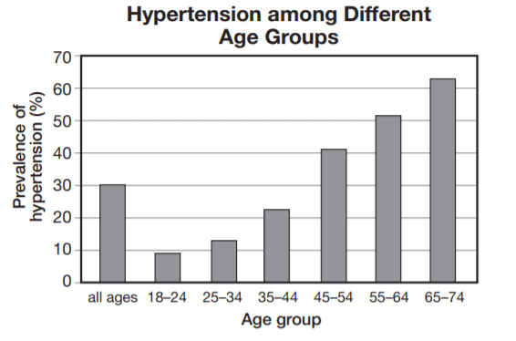
- A). The prevalence of hypertension is higher than average in the 35–44 age group.
- B). The prevalence of hypertension is highest in the 45–54 age group.
- C). The prevalence of hypertension increases with age.
- D). No teenager suffers from hypertension.
- E). . All senior citizens suffer from hypertension.
Answer: _____

Q15. The following pie chart illustrates the relative productivity (new plant material produced in one year) of different biomes. Based on the chart, which biome has the largest effect on the overall productivity?
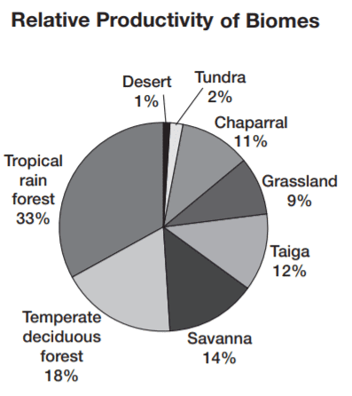
- A). chaparral
- B). savanna
- C). tropical rain forest
- D). desert
- E). temperate deciduous forest
Answer: _____

Q16. In 1969, two scientists devised an experiment to test a hypothesis that the number of species in an ecosystem depends on the area of the ecosystem. They counted all the arthropod species on a few very tiny islands. They then exterminated all the arthropods (mostly insects) with a pesticide. Over six months, they monitored the gradual repopulation of the island and noticed that by the end of the observation period, each island had almost the same number of species as it had before pesticide was used. However, the kinds of species that arrived often differed from the
species that were on the island prior to pesticide use. Here is a chart that illustrates the results.
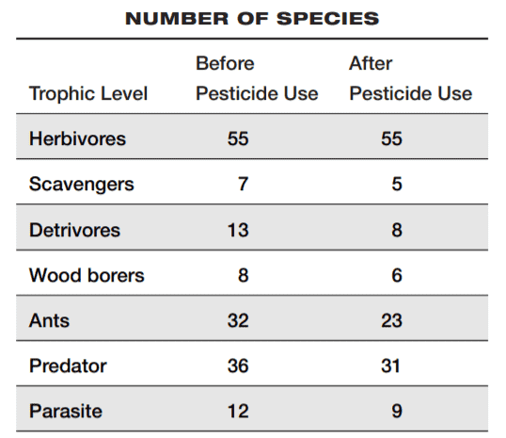
Based on the chart, which trophic level suffered the greatest net loss (number of species) in diversity?
- A). herbivores
- B). scavengers
- C). detrivores
- D). wood borers
- E). ants
Answer: _____

Questions 17 and 18 are based on the following passage.
A science student hypothesized that the rate of evaporation of water depends on the shape of the container the water is placed in. She decided to measure the amount of water evaporated when 300 ml of water in five different containers was heated from room temperature to 90° C on preheated hot plates. She used five cylindrical 500-milliliter glass containers, each having the same wall thickness but a different base radius and height. In other words, some containers were narrow and tall, others were wide and shallow. The following table lists the dimensions of the containers and the amount of water initially present.
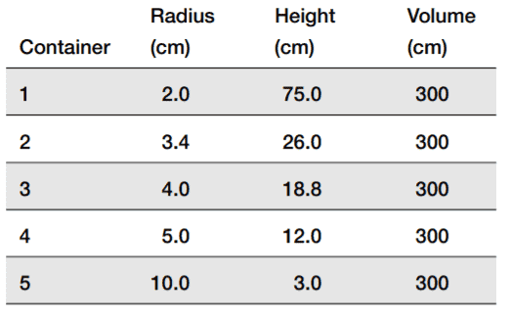
She placed each container, containing the same amount of water, on a hot plate, and placed a thermometer in each to monitor the temperature. She noticed that the temperature was increasing faster in the containers with a larger radius. After some time, the temperature in the 10-cm radius container reached the set 90° C. Following container 5, the water in containers 4, 3, 2, and 1, in that order, reached the set temperature. The student checked the volume of the water in each container and found that it was lower than 300 ml. She also found that
the decrease in volume was highest in the container with the largest radius. In container 1, volume decrease was barely detectable.
Q17.What can the student conclude from the data?
- A). The greater the radius of the container, the lower the rate of evaporation.
- B). The greater the radius of the container, the higher the rate of evaporation.
- C). The radius of the container is not related to the rate of evaporation.
- D). The greater the radius of the container, the slower it reaches the set temperature.
- E). The smaller the radius of the container, the faster it reaches the set temperature.
Answer: _____

Q18. Which two statements are valid objections to the experimental setup?
I. All the containers were filled with the same amount of water.
II. A different hot plate was used to heat water in different containers.
III. Water in different containers was heated for different amounts of time.
IV. The containers were not filled completely
- A). I and II
- B). I and III
- C). I and IV
- D). II and III
- E). II and IV
Answer: _____

Q19. The following graph shows how the concentration (amount per unit volume) changes with
time. What information can be obtained from the data?
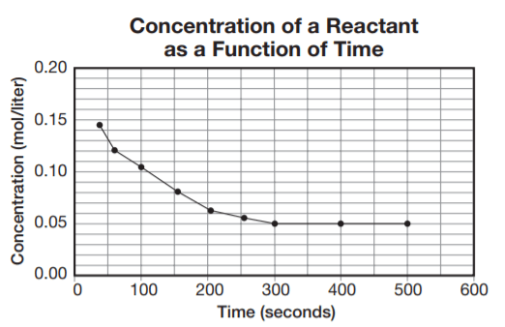
- A). The amount of reactant does not change with time
- B). The amount of product is decreasing
- C). The amount of reactant first decreases and then stays constant.
- D). After 500 seconds, all of the reactant is used.
- E). At 300 seconds, the concentration of the reactant is at maximum.
Answer: _____

Questions 20 and 21 are based on the following passage
Is Pluto a Planet?
Based on perturbations in Neptune’s orbit, the search for a ninth planet was conducted and Pluto was discovered in 1930. Pluto orbits the sun just like the other eight planets, and it has a moon, Charon, and a stable orbit. Based on its distance from the sun, Pluto should be grouped with the planets known as gas giants. In addition, Pluto, like the planet Mercury, has little or no atmosphere. Pluto is definitely not a comet because it does not have a tail like a comet when it is near the sun. Pluto is also not an asteroid, although its density is closer to an
asteroid than to any of the other planets. Pluto is a planet because it has been classified as one for more than sixty years since its discovery
Q20. Which argument supporting the classification of Pluto as a planet is the weakest?
- A). Pluto orbits the sun just like the other eight planets.
- B). Pluto has a moon.
- C). Pluto has a stable orbit.
- D). Pluto, like the planet Mercury, has little or no atmosphere.
- E). Pluto has been classified as a planet for more than sixty years since the discovery.
Answer: _____

Q21. Which one of the following statements is NOT backed with an explanation?
- A). Pluto is like a planet.
- B). Pluto should be grouped with planets known as gas giants.
- C). Pluto is like Mercury.
- D). Pluto is not a comet.
- E). Pluto is not an asteroid.
Answer: _____
Q22. The instrument shown in this picture can be used to study
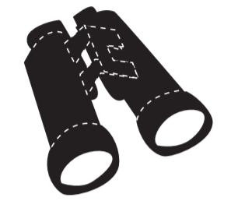
- A). cell organelles.
- B). the flight pattern of birds.
- C). the movement of stars in other galaxies.
- D). old manuscripts.
- E). human vision defects.
Answer: _____

Q23. A large surface area results in a high rate of cooling. This is why we tend to curl up when we sleep in a cold room and spread our limbs out when we sleep in a very hot room. Which of the following is an example where this principle is used in technology?
- A). Refrigerators can be used to cool containers of milk with large surface areas.
- B). Fans that cool computers are often ribbed to increase the surface area for cooling.
- C). Airplanes are shaped to minimize heat loss in the cabin
- D). Heat packs are designed to have a large surface area.
- E). Microwave ovens are designed to completely close during food preparation.
Answer: _____
Q24. The amount of dissolved gas in a liquid solution depends on the pressure of the gas. Under a high pressure, greater amounts of gas can be dissolved. The pressure is used to increase the solubility of carbon dioxide gas in
- A). fish ponds
- B). cereals.
- C). carbonated drinks.
- D). milk.
- E). gasoline.
Answer: _____
Questions 25 and 26 are based on the following diagram.
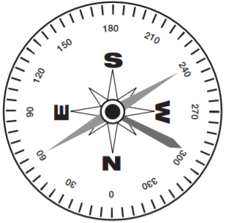
Q25. This instrument is used to
- A). determine the direction of the wind.
- B). determine the directions of the world.
- C). find the nearest piece of land when navigating the seas.
- D). find underground waters.
- E). determine the direction of water flow.
Answer: _____
Q26. This instrument works because
- A). it has an internal clock.
- B). the needle points to the direction of minimum pressure
- C). the needle changes position depending on the position of the sun.
- D). the Earth has two magnetic poles.
- E). the temperatures on Earth’s poles are very low.
Answer: _____
Questions 27 and 28 are based on the following passage
Farm animals can carry salmonella, a kind of bacteria that can cause severe food poisoning. However, animals fed antibiotics can carry especially deadly strains of salmonella. In Minnesota in 1983, 11 people were hospitalized with salmonella poisoning. This number itself was not striking at all. Forty thousand Americans are hospitalized with salmonella poisoning every year. What was striking about the cases in Minnesota was that each patient had severe symptoms and all the patients were infected with the same, rare strain of salmonella, resistant to several common antibiotics. A young scientist, Scott Holmberg, noted that eight patients were taking the same antibiotics for sore throats. He ruled out the possibility that the antibiotics themselves were infected with the bacteria because three of the patients were not taking antibiotics at all. He later showed that the people were infected with salmonella prior to taking the antibiotics, but that the antibiotics triggered the onset of salmonella poisoning. He postulated that salmonella suddenly flourished when the patients took antibiotics because the antibiotics killed off all other competing bacteria. He was also able to trace the antibiotic resistant salmonella to the beef that was imported to Minnesota from a farm in South Dakota, at which cattle were routinely fed antibiotics and at which one calf died of the same strain of salmonella.
Q27. As a result of this finding, the Food and Drug Administration should
- A). carefully regulate the prescription of antibiotics for sore throats.
- B). prevent the export of meat from South Dakota to Minnesota.
- C). limit the practice of feeding antibiotics to cattle.
- D). take the antibiotic that caused salmonella off the market.
- E). require a special prescription for antibiotics resistant to salmonella.
Answer: _____

Q28. Based on the passage, which one of the following statements is false?
- A). Salmonella poisoning is a common bacterial infection.
- B). Some strands of bacteria are resistant to antibiotics.
- C). Antibiotics kill off bacteria that are not resistant to antibiotics.
- D). Antibiotics transmit salmonella.
- E). Farm animals can carry salmonella.
Answer: _____
Questions 29 through 31 are based on the passage below and the table is even below.
Minerals are an important component of the human diet. Some minerals are needed in relatively large amounts. These include calcium, phosphorus, potassium, sulfur, chlorine, and magnesium. Others, including iron, manganese, and iodine, are needed in smaller amounts. Humans need 26 minerals all together, but some of them are only required in tiny amounts. Some minerals, such as lead and selenium, are harmful in large quantities. Dietary supplements can decrease the chance of mineral deficiencies listed in the table below, but should be taken with great care, since overdose can lead to poisoning.
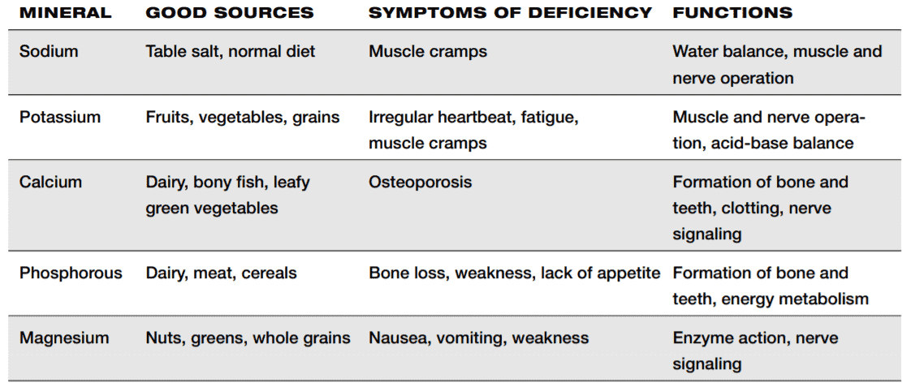
Q29. Taking several iron supplements per day can
- A). decrease the chance of bone loss.
- B). make you stronger.
- C). help relieve PMS symptoms.
- D). cause poisoning.
- E). make up for an unbalanced diet.
Answer: _____
Q30. Which of the minerals listed in the table are you most likely lacking if you experience irregular heartbeat?
- A). sodium
- B). potassium
- C). calcium
- D). phosphorous
- E). magnesium
Answer: _____
Q31. Which two minerals are necessary for formation of healthy bones and teeth?
- A). calcium and magnesium
- B). calcium and phosphorous
- C). calcium and potassium
- D). calcium and sodium
- E). sodium and magnesium
Answer: _____
Q32. Which of the following is the most common result of prolonged excessive alcohol consumption?
- A). heart attack
- B). brain tumor
- C). lung cancer
- D). liver damage
- E). cataracts
Answer: _____

Q33. Which of the following could be transmitted through kissing?
- A). lung cancer
- B). brain tumor
- C). flu
- D). diabetes
- E). Down’s syndrome
Answer: _____

Q34. Through friction, energy of motion is converted to heat. You use this in your favor when you
- A). wear gloves to make your hands warm.
- B). rub your hands together to make them warm.
- C). soak your hands with hot water to make them warm.
- D). place your hands near a fireplace to make them warm.
- E). hold a cup of tea to make your hands warm.
Answer: _____
Q35. The boiling point of water decreases with increasing pressure. At high altitudes, the atmospheric pressure is lower than at sea level. Where would you expect to find the highest boiling point temperature of water?
- A). in the Grand Canyon Valley
- B). at sea level
- C). at the base of Mount Everest
- D). at the top of Mount Everest
- E). at the top of a small hill
Answer: _____
36. Which of the following energy sources causes the least pollution to the environment?
- A). coal
- B). nuclear power
- C). gasoline
- D). solar
- E). oil
Answer: _____
Questions 37 and 78 are based on the following passage.
Radiation from radioisotopes can be used to kill cancer cells. Chemist Marie Curie received two Nobel Prizes for her work with radioisotopes. Her work led to the discovery of the neutron and synthesis of artificial radioactive elements. She died of leukemia at 67, caused by extensive exposure to radiation. Curie never believed that radium and other materials she worked with were a health hazard. In World War I, glowing
radium was used on watch dials to help soldiers read their watches in the dark and to synchronize their attacks. Unfortunately, women who worked in factories were drawing their radium stained brushes to fine points by putting them between their lips. As a result, their teeth would glow in the dark. But this was an amusement for children more than a cause of worry. About ten years later, the women developed cancer in their jaws and mouths and had problems making blood cells. This exposed the dangers of radiation.
Q37. Based on the information in the passage, which statement about radioisotopes is false?
- A). Radioisotopes can kill cancer cells.
- B). Radioisotopes can cause cancer.
- C). A radioisotope can glow in the dark.
- D). Einstein received the Nobel Prize for working with isotopes.
- E). A radioisotope was used in watch dials.
Answer: _____
Q38. Which dangers of radiation were mentioned in the passage?
I. Radiation can cause genetic mutations.
II. Radiation can lead to leukemia.
III. Radiation can cause chemotherapy.
- A). danger I only
- B). danger II only
- C). danger III only
- D). dangers I and II
- E). dangers II and III
Answer: _____
Questions 39 and 40 are based on the following passage.
In the past, people thought that the Earth was flat and that a ship that sailed too far would fall off the edge of the world. The Earth appears flat because the Earth is too large for humans on Earth to see its curvature. Several events helped shed the misconceptions. For one, during a lunar eclipse, the Earth is positioned between the sun and the moon. It eclipses the moon by casting a shadow on it. The shadow the Earth casts is round. When Magellan circumnavigated the Earth, he proved that one could not fall off the edge of the Earth, because the Earth was round and had no edges. Finally, space missions provided us with images of our round Earth from far away and showed us how beautiful our planet looks, even from a distance.
Q39. In the passage, what was cited as proof that the Earth is round?
I. Earth casts a round shadow on the moon during a lunar eclipse.
II. Earth revolves around the sun.
III. Magellan circumnavigated the Earth.
IV. images from space
- A). I and II
- B). I, II, and III
- C). I, II, and IV
- D). I, III, and IV
- E). II, III, and IV
Answer: _____
Q40. With which misconception about the Earth is the passage concerned?
- A). that the Earth turned
- B). that the Earth was in the center of the solar system
- C). that the Earth was flat
- D). that the Earth was created at the same time as the sun
- E). that the Earth could be eclipsed by the sun
Answer: _____

Answers Keys and Explanation Link
>> GED Science Practice Test

