GED Social Studies Practice Test 1
Read each question carefully. The questions are multiple-choice and may be based on a passage, table, or illustration. Select the best answer for each question.
Question 1 refers to the map below.
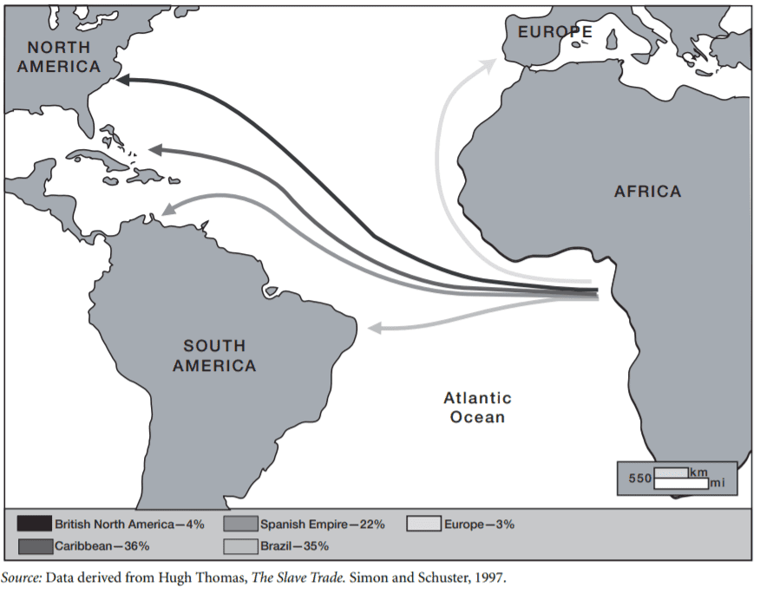
Q1. According to the information given in the map, which of the following conclusions can be drawn?
- A). The British colonies were the main destination of African slaves.
- B). South America did not allow the importation of slaves.
- C). Most slaves were sent to work on sugar plantations in Brazil and in the Caribbean.
- D). South America has a large population of African origin today.
- E). The main slave-trading region in Africa stretched 550 miles long.
Answer : ___
Questions 2 through 5 are based on the map below.
Time Zones across the Continental United States
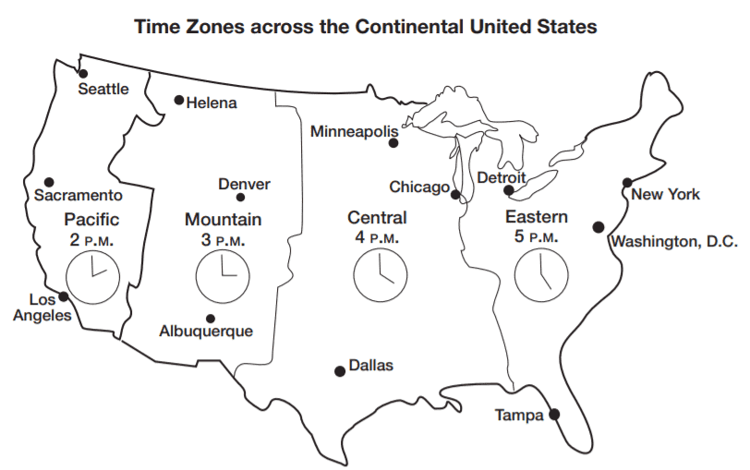
The Earth is divided into 24 time zones. The Earth rotates 15 degrees in one hour, so each time zone equals 15 degrees of
latitude. The map illustrates the four time zones across the continental United States.
Q2. According to the map, what time is it in Dallas when it is noon in Sacramento?
- A). 2:00 P.M.
- B). 3:00 P.M.
- C). 2:00 A.M.
- D). 1:00 A.M.
- E). 11:00 P.M.
Answer : ___
Q3. What time is it in Sacramento, CA, when it is midnight in Tampa, FL?
- A). 1:00 A.M.
- B). 12:00 P.M.
- C). 9:00 A.M.
- D). 9:00 P.M
- E). 10:00 P.M.
Answer : ___
Q4. As a traveler moves west, she can expect to
- A). change time zones.
- B). move into an earlier time zone for every 15 degrees of latitude she travels.
- C). experience jet lag.
- D). move into an earlier time zone for every 15 degrees of longitude she travels.
- E). move into a later time zone for every 15 degrees of latitude she travels.
Answer : ___
Q5. In past presidential elections, television networks have made predictions about which candidate is likely to win before the polls closed throughout all of the nation’s time zones. Which of the following statements explains why this would anger some voters?
- A). The polls close later in New York than in Chicago
- B). Voters in the Central time zone want to know who won in the eastern states.
- C). Polls in the Pacific time zone open earlier if voters want their votes to be counted.
- D). Polls close one hour later in the Mountain time zone than in the Central time zone.
- E). Predictions based on voting in eastern time zones influence those who have not yet voted in the more western time zones.
Answer : ___

Questions 6 through 8 refer to the following graphs.
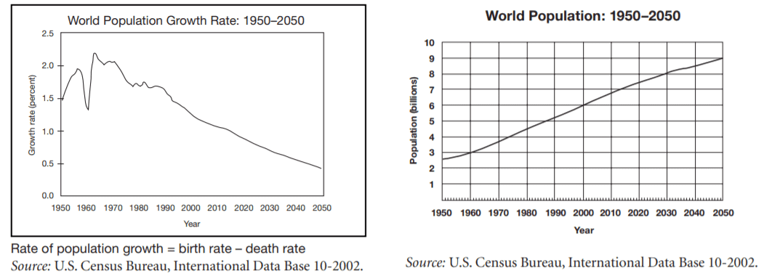
Q6. The greatest increase in population growth rate between 1950 and 2000 occurred in
- A). 1956–1957.
- B). 1962–1963.
- C). 1990–2000.
- D). 2000–2001.
- E). 2001–2002.
Answer : ___
Q7. The world population growth rate dropped one percentage point between the mid-1950s and 1960. Which of the following best explains this occurrence?
- A). There were more births and fewer deaths in the mid-1950s than there were in 1960.
- B). A baby boom in the decade after World War II caused a spike in the birth rate.
- C). The introduction of the birth control pill in 1960 in the United States helped slow the birth rate
- D). There were more births in 1960 than there were in the mid-1950s.
- E). There were more deaths in 1960 than there were in the mid-1950s.
Answer : ___
Q8. Which of the following statements is proved by the information in the two graphs?
- A). The population will reach its limit by 2050.
- B). When the rate of population growth decreases, so does the population.
- C). When the rate of population growth increases, so does the population.
- D). The rate of population growth will reach an all-time low in 2050.
- E). Even though the rate of population growth is decreasing, the population is increasing.
Answer : ___

Questions 9 and 10 are based on the following passage.
Even though acid rain looks, feels, and even tastes like clean rainwater, it contains high levels of pollutants. Scientists believe car exhaust and
smoke from factories and power plants are the main causes of acid rain, but natural sources like gases from forest fires and volcanoes may also contribute to the problem. Pollutants mix in the atmosphere to form fine particles that can be carried long distances by wind. Eventually, they return to the ground in the form of rain, snow, fog, or other precipitation. Acid rain damages trees and causes the acidification of lakes and streams, contaminating drinking water and damaging aquatic life. It erodes buildings, paint, and monuments. It can also affect human health. Although acid rain does not directly harm people, high levels of the fine particles in acid rain are linked to increased risk for asthma and bronchitis. Since the 1950s, the increase of acid rain has become a problem in the northeastern United States, Canada, and western Europe.
Q9. Which of the following natural resources is least likely to be affected by acid rain?
- A). animal life
- B). plant life
- C). coal reserves
- D). water
- E). forest
Answer : ___
Q10. Which of the following is NOT a cause of acid rain?
- A). human activity
- B). natural phenomena
- C). volcanoes
- D). lakes and streams
- E). traffic
Answer : ___
Questions 11 and 12 refer to the following form.
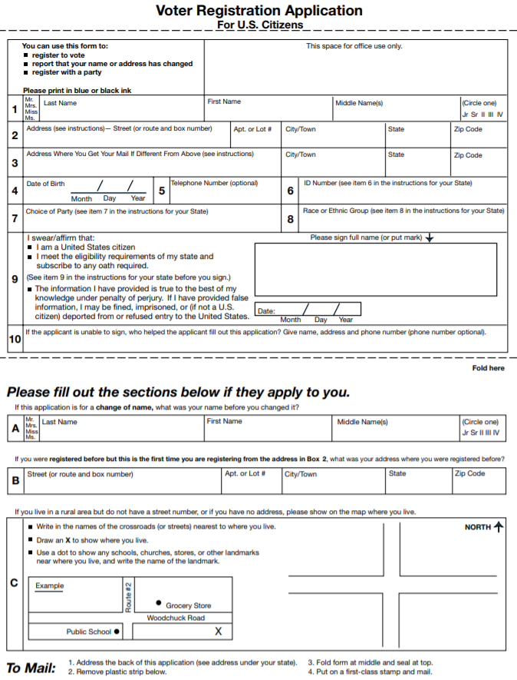
Q11. Which of the following is NOT a purpose of this form?
- A). notifying the government that you have changed your name
- B). registering with a political party
- C). applying for U.S. citizenship
- D). registering to vote in an upcoming local election
- E). indicating that you have moved and will be voting in another district
Answer : ___
Q12. Which of the following expresses a fact rather than an opinion?
- A). States have different requirements about who is eligible to vote.
- B). The voting age should be changed from 18 to 21 years of age.
- C). Every state should institute a “voter-motor” program in which people can register to vote at the same time that they are registering their motor vehicle.
- D). The government should allow noncitizens to vote.
- E). Voting should be considered a privilege, not a right.
Answer : ___
Questions 13 through 15 are based on the following map.
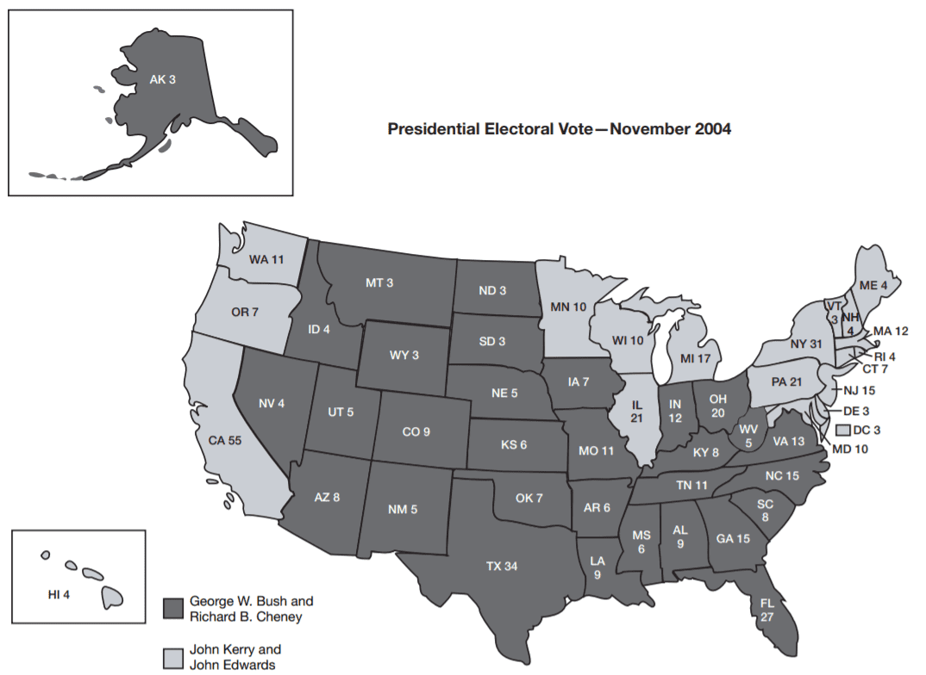
The electoral college is a group of electors who choose the president and vice president. Each state is allowed the same number of electors as its total number of U.S. senators and representatives—so each state has at least three electors. In most states, the candidate who wins the most popular votes earns that state’s electoral votes.
Source: National Archives and Records Administration.
Q13. Based on the information in the map, which of the following might be true of Kerry’s campaign strategy?
- A). It focused on winning the states in the southeast.
- B). Kerry targeted his campaign efforts in his home state of Massachusetts.
- C). It targeted states that have large populations and a large number of electoral votes.
- D). It focused on winning most of the states with small populations.
- E). Kerry campaigned vigorously in George W. Bush’s home state of Texas.
Answer : ___

Q14. Which of the following is NOT a true statement?
- A). George W. Bush won a larger number of states.
- B). Kerry was popular in New England.
- C). If Kerry had won Florida’s electoral votes, he would have become president.
- D). If Kerry had won New Hampshire’s electoral votes, he would have become president.
- E). Bush did not appeal to most voters on the west coast.
Answer : ___
Q15. Which of the following conclusions can you make from the information in the map?
- A). Women are more likely than men to vote for the Democratic Party
- B). Increasing numbers of Americans consider themselves political independents.
- C). The Sunbelt—the southern and southwestern states—was once a stronghold of the Democratic Party.
- D). There were distinct regional differences in voting patterns.
- E). You can not make any predictions about voting patterns based on region.
Answer : ___
Questions 16 and 17 are based on the following quotation.
“Today, education is perhaps the most important function of state and local governments. Compulsory school attendance laws and the great expenditures for education both demonstrate our recognition of the importance of education to our democratic society. It is required in the performance of our most basic public responsibilities, even service in the armed forces. It is the very foundation of good citizenship. Today, it is a principal instrument in awakening the child to cultural values, in preparing him for later professional training, and in helping him to adjust normally to his environment. In these days, it is doubtful that any child may reasonably be expected to succeed in life if he is denied the opportunity of an education. Such an opportunity, where the state has undertaken to provide it, is a right which must be made available to all on equal terms.
We come then to the question presented: Does segregation of children in public schools solely on the basis of race, even though the physical facilities and other ‘tangible’ factors may be equal, deprive the children of the minority group of equal educational opportunities? We believe that it does.”
—U.S. Supreme Court Chief Justice Earl Warren in a 1954 decision that ruled that separate schools for blacks and whites were unconstitutional
Source: Legal Information Institute, Cornell Law School, Brown v. Board of Education of Topeka.
Q16. Which of the following is NOT a purpose of education as expressed in the quotation?
- A). to expose children to values
- B). to explain the government’s education budget
- C). to prepare those who might serve the country as soldiers
- D). to produce good citizens
- E). to give kids a chance to succeed at life
Answer : ___

Q17. According to the passage, how might the court define “equal educational opportunity”?
- A). schools with the same quality of teaching
- B). schools with the same quality of facilities and materials
- C). schools that only admit students based on sex
- D). schools that separate minority students to give them a better chance
- E). schools of the same quality and welcome all students regardless of race
Answer : ___
Question 18 is based on the following passage.
The First Amendment to the U.S. Constitution states the following: “Congress shall make no law respecting an establishment of religion, or
prohibiting the free exercise thereof; or abridging the freedom of speech, or of the press; or the right of the people peaceably to assemble,
and to petition the Government for a redress of grievances.”
Q18. Which of the following situations is NOT protected by the First Amendment?
- A). a New York Times editorial criticizes the government’s foreign policy
- B). a neo-Nazi group applies for a permit and stages a rally in a public square
- C). a police officer reads a suspect his rights
- D). a group meets in a chapel to worship
- E). students protest federal budget cuts in education
Answer : ___
Question 19 is based on the following passage.
The Sixth Amendment of the U.S. Constitution states, “In all criminal prosecutions, the accused shall enjoy the right to a speedy and public trial, by an impartial jury of the State and district wherein the crime shall have been committed, which district shall have been previously ascertained by law, and to be informed of the nature and cause of the accusation; to be confronted with the witnesses against him; to have compulsory process for obtaining witnesses in his favor, and to have the Assistance of Counsel for his defence.”
Q19. Which of the following instances is NOT protected by the Sixth Amendment?
- A). A person accused of a crime silently prays before his trial begins.
- B). A person accused of drug trafficking hires a lawyer to defend him.
- C). A trial is moved to another area because no jurors could be found who had not heard of the crime and had an opinion about who
committed it
- D). A lawyer informs an accused person of her charges
- E). A lawyer cross-examines witnesses who testify against her client.
Answer : ___
Question 20 is based on the following graph.
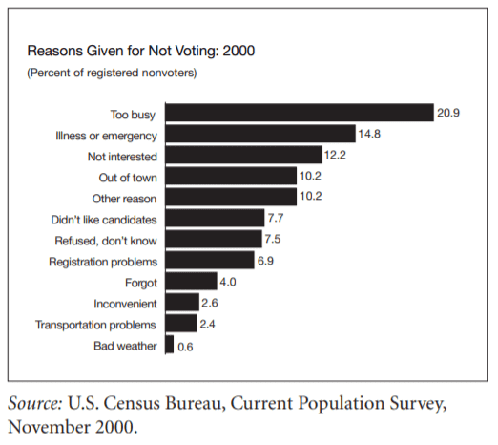
Q20. Based on the information in the graph, which of the following proposals might best improve the voting rate?
- A). Distribute umbrellas to all households to encourage people to vote on rainy election days.
- B). Organize buses to help people get to voting places.
- C). Send reminders to registered voters so they do not forget to vote.
- D). Reschedule Election Day to a weekend so that people who are busy at work and at school can be available to vote.
- E). Provide more interesting candidates that inspire people to vote.
Answer : ___

Question 21 is based on the following graph.
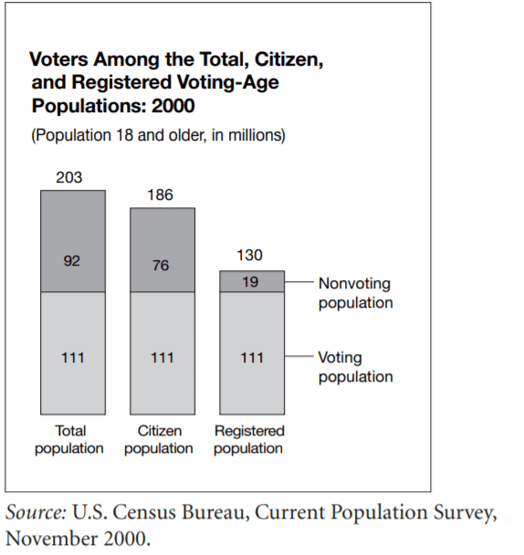
Q21. According to the graph, how many eligible U.S. citizens are NOT registered to vote?
- A). 19 million
- B). 56 million
- C). 76 million
- D). 92 million
- E). 130 million
Answer : ___
Questions 22 and 23 refer to the following passage.
The U.S. Constitution gives the president the power to veto, or reject, a bill passed by Congress. The president sends the proposed law back to Congress and states his objections. Because it takes a two-thirds vote from both the House of Representatives and the Senate to override a veto, Congress often changes the bill to make it more acceptable to the president. Sometimes, Congress adds provisions to a bill that the president strongly favors. The president does not have the power of line-item veto, in which lines or parts of a bill can be rejected individually. The president must accept or reject the bill as Congress has written it.
Q22. Which of the following statements can you infer from the passage?
- A). Congress is more powerful than the president.
- B). Congress tries to get the president to accept its provisions by attaching provisions to a bill that the president supports.
- C). A president is more effective when members of the same political party are the majority in Congress.
- D). If a president vetoes a bill, there is no way to get it passed into law.
- E). Bills that the president vetoes are unconstitutional.
Answer : ___

Q23. Which of the following conclusions can you make based on the passage?
- A). a. It is easier to rewrite and make a bill more acceptable to the president than it is to override a veto.
- B). It is easier to override a veto than it is to rewrite and make a bill more acceptable to the president.
- C). The U.S. Constitution gives the president the power to edit the bills he receives from Congress.
- D). The system of checks and balances ensures that president has no influence over the lawmaking branch of government.
- E). Presidents rarely use their power to veto.
Answer : ___

Questions 24 and 25 are based on the following quotations.
“We might as easily reprove the east wind, or the frost, as a political party, whose members, for the most part, could give no account of their
position, but stand for the defence of those interests in which they find themselves.” —Ralph Waldo Emerson (1803–1882), U.S. essayist
“A party of order or stability, and a party of progress or reform, are both necessary elements of a healthy state of political life.” —John Stuart Mill (1806–1873), British philosopher
Q24. Which of the following party systems would Emerson most likely support?
- A). one in which with citizens are loyal to a political party at all costs
- B). a two-party system
- C). a system with a liberal party that advocates for change and a conservative party that maintains tradition
- D). one in which citizens are independent and think for themselves
- E). a multi-party system
Answer : ___

Q25. Which of the following party systems would Mill most likely support?
- A). one in which with citizens are loyal to a political party at all costs
- B). a two-party system
- C). a system with a liberal party that advocates for change and a conservative party that maintains tradition
- D). one in which citizens are independent and think for themselves
- E). a multi-party system
Answer : ___

Questions 26 and 27 refer to the following passage.
The U.S. Constitution does not explicitly give the power of judicial review to the Supreme Court. In fact, the court did not use this power—which gives it the authority to invalidate laws and executive actions if they conflict with the Constitution—until the 1803 case of Marbury v. Madison. In that case, Chief Justice John Marshall ruled that a statute was unconstitutional. He argued that judicial review was necessary if the court was to fulfill its duty of upholding the Constitution. Without it, he felt that the legislature would have a “real and practical omnipotence.” Moreover, several of the Constitution’s framers expected the court to act in this way. Alexander Hamilton and James Madison emphasized the importance of judicial review in the Federalist Papers, a series of essays promoting the adoption of the Constitution. However, the power of judicial review continues to be a controversial power because it allows the justices—who are appointed rather than elected—to overturn laws made by Congress and state lawmaking bodies
Q26. Which of the following statements is an implication of judicial review?
- A). The Constitution is a historic document with little influence over how the government operates today.
- B). The Constitution must explicitly state which branch of government is to have what authority.
- C). The framers never meant for the Supreme Court to have this power
- D). If Supreme Court justices were elected, the power of judicial review would be justified.
- E). The Constitution is a living document that continues to be interpreted.
Answer : ___
Q27. Which of the following best describes the purpose of judicial review?
- A). to declare a law unconstitutional
- B). to follow public opinion polls
- C). to determine the country’s changing needs
- D). to propose new laws
- E). to adapt the Constitution to what the court feels is right
Answer : ___
Questions 28 and 29 are based on the following excerpt. (History)
Beginning in 1958 . . . local NAACP [National Association for the Advancement of Colored People] chapters organized sit-ins, where African Americans, many of whom were college students, took seats and demanded service at segregated all-white lunch counters. It was, however, the sit-in demonstrations at Woolworth’s store in Greensboro, North Carolina, beginning on February 1, 1960, that caught national attention and sparked other sit-ins and demonstrations in the South. One of the four students in the first Greensboro sit-in, Joe McNeil, later recounted his experience: “ . . . we sat at a lunch counter where blacks never sat before. And people started to look at us. The help, many of whom were black, looked at us in disbelief too. They were concerned about our safety. We asked for service, and we were denied, and we expected to be denied. We asked why we couldn’t be served, and obviously, we weren’t given a reasonable answer, and it was our intent to sit there until they decided to serve us.
”Source: www.congresslink.org and Henry Hampton and Steve Fayer (eds.) Voices of Freedom: An Oral History of the Civil Rights Movement from the 1950s through the 1980s. Vintage Paperback, 1995.
Q28. Joe McNeil has not directly stated, but would support, which of the following statements?
- A). Without the sit-in in Greensboro, NC, the civil rights movement would never have started.
- B). Woolworth’s served affordable lunches.
- C). Local NAACP chapters were causing trouble and upsetting citizens.
- D). Nobody was surprised when black college students took a seat at the all-white lunch counter
- E). The college students showed courage when they participated in the Greensboro sit-in.
Answer : ___
Q29. What is the author’s purpose in including Joe McNeil’s quotation?
- A). to show that young people are the most likely to push for societal change
- B). to demonstrate that everyone has a different point of view
- C). to give a firsthand account of what has become a historic event
- D). to discount the importance of the civil rights movement
- E). to show that the college students had not intended to create a stir
Answer : ___

Questions 30 and 31 refer to the following photograph and passage.
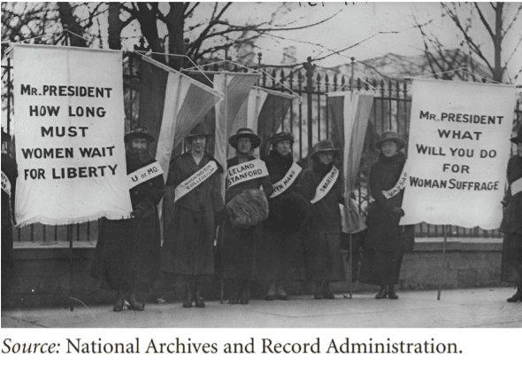
After 72 years of campaigning and protest, women were granted the right to vote in 1920. Passed by Congress and ratified by 36 of the then 48 states, the Nineteenth Amendment of the U.S. Constitution states, “The right of citizens of the United States to vote shall not be denied or abridged by the United States or by any State on account of sex.”
Q30. Who are the women in this photograph addressing?
- A). other women who say they don’t want the right to vote
- B). President Woodrow Wilson
- C). abolitionists
- D). suffragettes
- E). isolationists
Answer : ___
Q31. With which of the following statements would the photographer most likely agree?
- A). Women should behave in a dignified and orderly manner even if they are protesting.
- B). Women stand outside the gates of governmental power
- C). The suffragettes would be more effective if they had more powerful slogans.
- D). Demonstrations are the most effective ways to influence lawmaking.
- E). Demonstrations are always ineffective.
Answer : ___
Question 32 is based on the following passage.
When European settlers arrived on the North American continent at the end of the fifteenth century, they encountered diverse Native American cultures—as many as 900,000 inhabitants with over 300 different languages. These people, whose ancestors crossed the land bridge from Asia in what may be considered the first North American immigration, were virtually destroyed by the subsequent immigration that created the United States. This tragedy is the direct result of treaties, written and broken by foreign governments, of warfare, and of forced assimilation.
Source: The Library of Congress, American Memory
Q32. What does the author of this passage believe?
- A). The U.S. government was faithful to its treaties with Native Americans
- B). Native Americans made up a homogenous group.
- C). The European settlers were responsible for the decimation of Native people.
- D). Native cultures were unsophisticated.
- E). The Europeans benefited from contact with Native cultures.
Answer : ___
Questions 33 and 34 are based on the following engraving
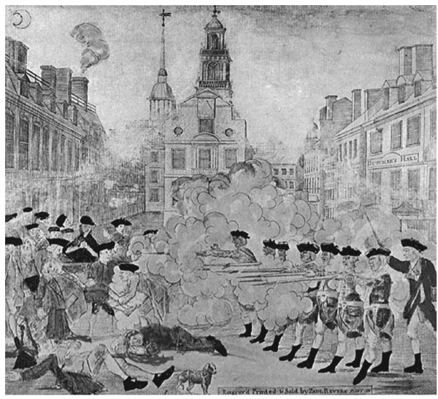
Paul Revere made and sold this engraving depicting the “Boston Massacre,” a pre-Revolutionary encounter between British troops and American colonists, in which five colonists were killed.
Source: HistoryCentral.com.
Q33. Which of the following messages did Paul Revere most likely want to convey in his engraving?
- A). American colonists should not protest the presence of British troops in Boston
- B). The British troops were defending themselves against rowdy gangs of colonists.
- C). British troops savagely killed unarmed citizens.
- D). Americans should willingly pay British taxes on imports of glass, paper, paint, and tea.
- E). British troops used only necessary force in dealing with the rioting crowd.
Answer : ___
Q34. What can you infer was Revere’s purpose in creating and selling the engraving?
- A). make a large profit for himself
- B). calm the rebellious spirit of Boston citizens
- C). create support for the British empire
- D). represent both sides of the event
- E). fuel the revolutionary cause
Answer : ___
Question 35 is based on the following passage.
German printer Johannes Gutenberg is often credited with the invention of the first printing press to use movable type. He used handset type to print the Gutenberg Bible in 1455. Although his invention greatly influenced printing in Europe, similar technologies were used earlier in China and Korea. Chinese printers used movable block prints and type made of clay as early as 1040, and Korean printers invented movable copper type about 1392.
Q35. What is the purpose of the paragraph?
- A). to praise the advances of printing technology
- B). to connect the early advances in printing with today’s technological advances
- C). to show that technological advances can develop in different geographical areas over periods of time
- D). to give credit to Gutenberg for the first movable-type printing press
- E). to show how Gutenberg’s invention made printed materials more widely available
Answer : ___

Answer Keys and Explanation
https://gotestprep.com/ged-social-studies-test/

