ASVAB Mechanical Practice Test
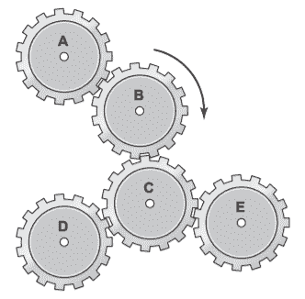
1. The diagram shows five gears. If gear B turns as shown, then the gears turning in the same direction are
- A. A and C.
- B. A and D.
- C. C and D.
- D. D and E.
2. What is the theoretical mechanical advantage in using this lever?
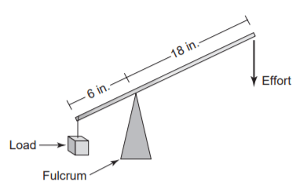
- A. 1
- B. 2
- C. 3
- D. 4
3. A wrench is used to turn a bolt that has 20 threads per inch. After 15 complete turns of the wrench, the bolt will have moved
- A. 1⁄4 inch.
- B. 1⁄2 inch.
- C. 3⁄4 inch.
- D. 1 inch.
4. A gear and pinion have a ratio of 5 to 1. If the gear is rotating at a speed of 150 revolutions per minute (rpm), the speed of the pinion is most nearly
- A. 750 rpm.
- B. 300 rpm.
- C. 150 rpm.
- D. 30 rpm.
5. In the diagram, water is flowing from left to right. What is true of the water after it enters the 3-inch pipe?
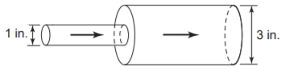
- A. Its pressure decreases, but its speed increases.
- B. Its pressure and speed both decrease.
- C. Its pressure and speed both increase.
- D. Its pressure increases, but its speed decreases.
6. What is the force F needed to balance this lever?
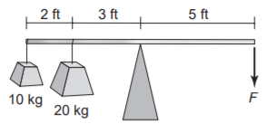
- A. 20 kg
- B. 22 kg
- C. 25 kg
- D. 30 kg
7. Gear A, with 48 teeth, meshes with gear B, with 12 teeth. For every rotation that gear A makes, how many rotations does gear B make?
- A. 1
- B. 2
- C. 4
- D. 8
8. Pushing a heavy concrete block up an inclined plane will be easier if you
- A. raise the angle of the plane.
- B. turn the block upside down.
- C. heat the block with an electric coil.
- D. put the block on a wheelbarrow.
9. These pipes and cylinders are part of a hydraulic mechanism. If the piston in cylinder A moves,
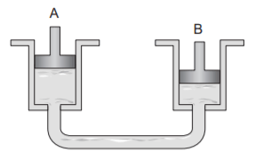
- A. the piston in cylinder B will move.
- B. the fluid in cylinder A will not move.
- C. the piston in cylinder B will not move.
- D. the fluid in cylinder A will move, but the fluid in cylinder B will not move.
10. A 3 ft × 6 ft tank is filled with 3,600 lb of water. What is the pressure on the bottom, in lb/ft2?
- A. 100
- B. 200
- C. 400
- D. 800
11. Which cannot bend without breaking?
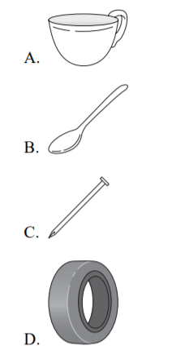
12. A knife blade is an example of which kind of simple machine?
- A. Pulley
- B. Wheel and axle
- C. Inclined plane
- D. Gear
13. In the pulley (sheave) system shown, pulley 1 is rotating at 80 rpm. How fast is pulley 2 rotating?
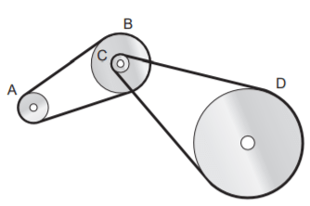
- A. 180 rpm
- B. 240 rpm
- C. 300 rpm
- D. 360 rpm
14. In the pulley system shown (above), which pulley is rotating the slowest?
- A. A
- B. B
- C. C
- D. D
15. Operating this car jack will take less effort if you
- A. add weight to the other side of the car.
- B. get a longer jack handle.
- C. open the hood of the car.
- D. replace the jack handle with one just like it made of wood.
16. Which material is best for the floor of a fireplace?
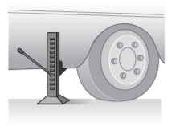
- A. Wood
- B. Plastic
- C. Stone
- D. Glass
17. What effort is required to lift the load?
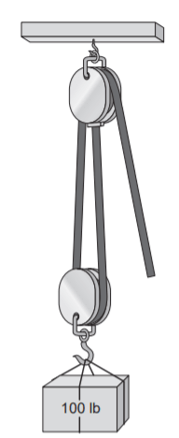
- A. 40 lb
- B. 50 lb
- C. 100 lb
- D. 200 lb
18. What makes the water flow out of the tank and through the siphon hose into the bucket?
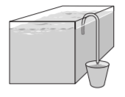
- A. Air pressure
- B. Water pressure
- C. The weight of the water
- D. Magnetism
19. In the diagram, gear B is an idler gear. If gear B is rotating clockwise,
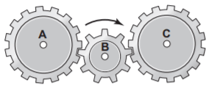
- A. gear A is rotating clockwise, but gear C is rotating counterclockwise.
- B. gear A and gear C are rotating clockwise.
- C. gear A and gear C are rotating counterclockwise.
- D. gear A is rotating counterclockwise, but gear C is rotating clockwise.
20. A wrench uses which simple machine to turn a bolt?
- A. Lever
- B. Inclined plane
- C. Pulley
- D. Wheel and axle
21. The diagram shows a box of books on a shelf supported by two posts. Which post bears the greater part of the weight?
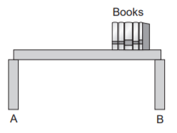
- A. Post A.
- B. Post B.
- C. Each post bears the same amount of weight.
- D. The shelf distributes the weight equally.
22. Water is flowing into the tank from the upper faucet at the rate of 240 gallons per hour and draining out of the tank through the lower faucet at a rate of 1 gallon per minute. How many more gallons of water will be in the tank after 6 minutes?
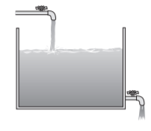
- A. 14
- B. 16
- C. 18
- D. 22
23. The diagram shows a rotating disk. When the disk rotates, which point travels farthest?
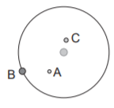
- A. Point A.
- B. Point B.
- C. Point C.
- D. Points B and C both travel the same distance.
24. Which flat cardboard pattern can be folded along the dotted lines to form the complete, totally enclosed box shown?
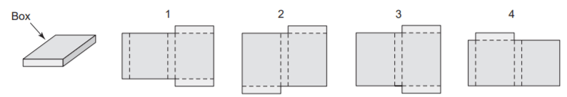
- A. 1
- B. 2
- C. 3
- D. 4
25. After the crank (A) rotates 9.5 times, where will the piston (B) be?
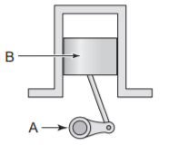
- A. In the same place as shown
- B. At the top of the cylinder
- C. At the bottom of the cylinder
- D. B or C

Answer Keys and Explanation
https://gotestprep.com/asvab-mechanical-comprehension-practice-test/

